Public Health Dorset
Pharmaceutical Needs Assessment
2025 – 2028 Draft

Produced by: Public Health Dorset
60-day consultation period:
Contributors: Jane Horne – Consultant in Public Health
Lee Robertson – Senior Public Health Analyst
Wilson Otitonaiye – Public Health Data Scientist
Rohan Mongru – Specialist Registrar in Public Health
Fiona Arnold - Community Pharmacy Integration Clinical lead
Louise Bate – Healthwatch Dorset Manager

Version Information:
v1.0 5/3/25 | Initial draft completed.
v1.1 10/3/25 | Consultant review
v1.2 19/3/25 | Healthwatch Dorset and pharmacy data added
v1.3 26/5/25 | Authors confirmed and added
v1.4 4/6/25 | Drivetime rationale added into section 6.1.

Contents
1. Executive summary 5
2. Introduction 6
2.1 Purpose of a pharmaceutical needs assessment (PNA) 6
2.2 HWB duties in respect of the PNA and pharmaceutical services 7
2.3 Contractors within the scope of the PNA 7
2.3.1Pharmacy contractors 7
2.3.2 Dispensing appliance contractors (DACs) 8
2.3.3 Dispensing doctors 8
2.4 Services within the scope of the PNA 8
2.4.1 Essential Services 9
2.4.2 Advanced Services 10
2.4.3 Enhanced Services 11
2.4.4 Clinical Governance 11
2.5 Pharmaceutical services provided by dispensing appliance contractors 11
2.5.1 Services Provided by All DACs 12
2.5.2 Advanced Services 12
2.5.3 Clinical governance 12
2.6 Pharmaceutical Services Provided by Dispensing Doctors 12
2.6.1 Eligibility 13
2.6.2 Services 13
2.6.3 Clinical Governance 13
2.7 Opening hours 13
2.7.1 Pharmacy Contractors 13
2.7.2 DACs 14
2.7.3 Dispensing doctors 14
2.8 National Context 14
3. Development of the PNA 16
3.1 PNA Steering Group 16
3.2 PNA development timeline 16
3.3 Localities 16
3.4 Data collation and mapping 18
3.5 Data Limitations 18
3.6 Public and Pharmacy engagement 19
3.7 Other sources of information 20
3.8 Identifying gaps 20
3.9 Equality and safety impact assessment 21
3.10 Formal Consultation 21
3.11 Review and Supplementary statements 21
4. Local Context 23
4.1 Dorset Council and BCP Council 23
4.2 Public Health Dorset 23
4.3 NHS Dorset 24
4.4 Our Dorset 24
4.5 Local Demographics 26
4.6 Our Dorset Joint Strategic Needs Narrative 31
4.7 Housing Growth 33
4.8 Car or Van Ownership 33
4.9 Identified patient groups 33
4.9.1 Asylum seekers and refugees 34
4.9.2 Ethnic Minorities 34
4.9.3 Disabilities 34
4.9.4 People with Learning Disabilities 35
4.9.5 Sex Workers 35
4.9.6 People who are Homeless or Sleeping Rough 35
4.9.7 Gypsies, Travellers, and Roma Groups 35
4.9.8 Prisoners 35
4.9.9 Students 36
4.9.10 Tourists 36
4.9.11 Military 36
5. Current Services 37
5.1 Health needs that can be met by pharmaceutical services 37
5.2 Number of Pharmacies and Access 37
5.3 Dispensing GPs 39
5.4 Essential Services 39
5.5 Advanced Services 39
5.6 Enhanced services 40
5.7 Locally commissioned services 40
5.8 Access to pharmaceutical services on public and bank holidays 42
5.9 Other Services 42
6. Gap Analysis 44
6.1 Access to Pharmaceutical Services in Dorset 44
6.2 Opening Hours 47
6.3 Choice of service provision 48
6.4 Meeting the needs of specific populations 48
6.5 Community pharmacy workforce 49
7. Conclusion 51
7.1 BCP Council necessary services – current provision 51
7.2 BCP Council necessary services – future provision 51
7.3 BCP Council other relevant services - current provision 51
7.4 BCP Council improvements and better access – gaps in provision 52
7.5 Dorset Council necessary services – current provision 52
7.6 Dorset Council necessary services – future provision 52
7.7 Dorset Council other relevant services - current provision 52
7.8 Dorset Council improvements and better access – gaps in provision 53
7.9 Our Dorset – local recommendations 53
8. Appendices 54
Appendix 1: Acronyms and definitions 54
Appendix 2: Legislation relating to PNAs 55
Appendix 3: Enhanced Service list (2025) 62
Appendix 4: Maps of PNA localities 63
Appendix 5: Consultation report 69
Appendix 6: List of community pharmacies and opening times 70
Appendix 7: List of distance selling pharmacies and opening times 90
Appendix 8: List of dispensing appliance contractors and opening times 91

1. Executive summary

A Pharmaceutical Needs Assessment (PNA) is a statement of the need for pharmaceutical services of an area. PNAs are used by The NHS to aid in the consideration of applications to join the pharmaceutical list for the area under The National Health Service (Pharmaceutical and Local Pharmaceutical Services) Regulations 2013, as amended. The national legislations and regulations, and key concepts and definitions are outlined in Chapter 2 Introduction, along with the commissioning organisations involved in the development of this PNA. The localities developed for the PNA together with the process of creating the PNA are described in Chapter 3 Development of the PNA.

Both councils have low levels of ethnically diverse residents, (discussed in Chapter 4 Local Context), with 82.4% and 93.9% respectively identifying as white British, compared to 73.5% for England and Wales. The highest proportion of BCP Council's ethnically diverse population is classified as “White Other” at 40%, while Dorset Council's highest proportion is also “White Other” at 40%.

Currently there are a total of 132 community pharmacies within the Dorset area (66 in BCP Council and 66 in Dorset Council), and 3 distance selling pharmacies (1 in BCP Council and 2 in Dorset Council) all of which provide essential services, and some of which provide advanced and enhanced services, as defined in Chapter 5 Current services. Also detailed in this chapter are services from 3 dispensing appliance contractors (2 in BCP council and 1 in Dorset council) and locally commissioned services in the area and details on other services than could impact community pharmacy.

This chapter uses information on current services to determine whether there is, or is likely to be, during the lifetime of this PNA, a gap in pharmaceutical service provisions for this area. It also identifies areas where improvements could be made. The analysis considers factors such as accessibility in terms of location and opening hours, choice of provider, and housing growth. Driving time has been chosen as the key measure of accessibility.

In Chapter 7 Conclusion, the PNA states that there is appropriate provision for the population that this PNA covers, with no current gaps and no future gaps identified over the three-year lifespan of this document. Future improvements and better access are best managed through working with existing contractors and improving integration with other services and within local areas rather than through the opening of additional pharmacies.

2. Introduction

This chapter introduces the PNA and examines national legislation and regulations, along with key concepts and definitions that define the PNA's scope.

This document has been produced by the Public Health and Communities Team at BCP Council and the Public Health and Prevention Team at Dorset Council for Bournemouth, Christchurch and Poole (BCP) Health and Wellbeing Board, and Dorset Health and Wellbeing Board. When referring to both geographical areas as one whole, the name Dorset will be used. When discussing commissioning organisations within these areas, they will be referred to by their full titles, such as BCP Council, Dorset Council, Our Dorset, NHS Dorset, or Public Health Dorset. Further discussion of these organisations can be found in Chapter 4.

2.1 Purpose of a pharmaceutical needs assessment (PNA)

The purpose of the PNA is to assess and outline how pharmaceutical services can meet the health needs of the population within a Health and Wellbeing Board’s area for up to three years. It closely links to the Joint Strategic Needs Assessment (JSNA), which focuses on the general health needs of the Our Dorset Integrated Care System. The PNA specifically addresses how these health needs can be met by pharmaceutical services commissioned by the NHS.

If a pharmacy or dispensing appliance contractor (DAC) wants to provide pharmaceutical services, they must apply to Primary Care Support England (PCSE) to be included in the pharmaceutical list for the Health and Wellbeing Board’s area where they wish to have premises. Generally, their application must offer to meet a need identified in the relevant PNA. However, there are exceptions for applications offering unforeseen benefits not anticipated when the PNA was published.

The PNA may also identify the need for additional premises, additional services, or improvements to existing services. These needs, improvements, or better access could be current or arise within the PNA's lifetime.

Whilst the PNA is primarily a document for the NHS to use in making decisions about pharmacies entering the market and other commissioning processes, it may also be utilised by local authorities to inform their own commissioning activities. With Integrated Care Boards (ICBs) taking responsibility for community pharmacy commissioning arrangements, supported by regional commissioning hubs, there may be changes over time in how ICBs and community pharmacies collaborate.

2.2 HWB duties in respect of the PNA and pharmaceutical services

The legislation containing a HWB’s specific duties in relation to PNAs can be found in Appendix 2: Legislation Relating to PNAs. In summary, a HWB must:

- Produce a PNA that complies with regulatory requirements.
- Have published their first PNA by 1 April 2015.
- Publish subsequent PNAs on a three-year basis or as directed by amended regulations. In 2021, the need for an updated PNA was moved to October 2022 due to the COVID-19 pandemic.
- Publish a subsequent PNA sooner if it identifies significant changes in the need for pharmaceutical services, unless doing so would be a disproportionate response.
- Produce supplementary statements in certain circumstances.

Given their role in developing the PNA, HWBs will also be consulted when pharmacies make applications to the NHS to:

- Provide pharmaceutical services from new provider premises.
- Move the location of their existing provider premises.
- Consolidate two or more pharmacies on one site.

The HWB will be informed of other changes where pharmacies are only required to give notice:

- Closure of a pharmacy (unless it is part of a consolidation application).
- Change of ownership.

Although Section 128A of the NHS Act 2006 required that each HWB publish a PNA, Section 198 of the Health and Social Care Act allowed two or more HWBs to make joint arrangements in how they discharge their functions. The 2015, 2018 and 2022 PNAs were all developed and published as a single PNA to cover the Dorset ICS in accordance with the statutory provisions. The Dorset HWB and the BCP HWB both agreed in 2024 that the 2025 PNA would again be developed and published as a single PNA document to cover the Dorset Integrated Care System.

2.3 Contractors within the scope of the PNA
The NHS must keep lists of contractors who provide pharmaceutical services around the HWB. The principal types of contractors are:

2.3.1Pharmacy contractors
Pharmacy contractors can be individual pharmacists (sole traders), partnerships of pharmacists, or companies operating pharmacies. The Medicines Act 1968 governs who can be a pharmacy contractor. All pharmacists and pharmacy premises must be registered with the General Pharmaceutical Council. Within this group, there are:

Community pharmacies – these provide in-person services from locations such as high street shops, supermarkets, and adjacent to doctors' surgeries. They dispense medicines and can sell non-prescription medicines under a pharmacist's supervision. They may also dispense appliances, though it is not mandatory. Community pharmacies operate under national terms of service as specified in Schedule 4 of the 2013 regulations and the Pharmaceutical Services (Advanced and Enhanced Services) (England) Directions 2013.

Local pharmaceutical services (LPS) contractors – A small number of community pharmacies operate under locally agreed contracts. These contracts always include the dispensing of medicines but can also cover a broader or narrower range of services, including those not traditionally associated with pharmacy. This flexibility allows services to be tailored to the specific needs of the area they serve.

Distance-selling pharmacies (DSPs) – These pharmacies cannot provide most services face-to-face. They operate under the same terms of service as community pharmacies, providing essential services and participating in the clinical governance system. However, they must provide these services remotely. For example, patients may post their prescriptions to a DSP, which will then dispense the item and deliver it to the patient's address by post or courier. DSPs interact with customers via telephone, email, or a website, delivering dispensed items to the preferred address. They are required to provide services to anyone in England and cannot limit their services to specific patient groups.

2.3.2 Dispensing appliance contractors (DACs)
DACs supply appliances such as stoma and incontinence aids, dressings, and bandages. They cannot supply medicines. There are no restrictions on who can operate as a DAC. DACs operate under national terms of service as set out in Schedule 5 of the 2013 regulations and the 2013 directions.

2.3.3 Dispensing doctors
Medical practitioners authorized to provide drugs and appliances in designated rural areas known as "controlled localities." Dispensing doctors can only dispense to their own patients. They operate under national terms of service as set out in Schedule 6 of the 2013 regulations.

2.4 Services within the scope of the PNA
The services that a PNA must include are defined in the NHS Act 2006 and the 2013 regulations.

Unlike GPs, dentists, and optometrists, The NHS does not hold contracts with most pharmacy contractors, except for Local Pharmaceutical Services contractors. Instead, these contractors provide services under terms set out in legislation.

Pharmacy contractors provide three types of services that fall within the definition of pharmaceutical services and may choose to supply appliances (see section 2.5 for appliance services).

For this PNA, 'necessary' services are defined as essential services. All other advanced, enhanced, and locally commissioned services are not considered necessary but secure improvements or better access to pharmaceutical services.

The Community Pharmacy Contractual Framework for 2019/20 to 2023/24 is the NHS's latest statement on what is expected of pharmacies providing NHS services. It supports the delivery of the NHS Long Term Plan and outlines schemes to support quality and sustainability. A revised framework from 24/25 is still in negotiation.

2.4.1 Essential Services
All pharmacies must provide these services:

- Dispensing of prescriptions: Supplying medicines and appliances ordered on NHS prescriptions (electronic and non-electronic), along with information and advice for safe and effective use by patients and carers. This includes maintaining records and the urgent supply of drugs or appliances without a prescription at the request of a prescriber.
- Dispensing of repeatable prescriptions: Managing and dispensing repeatable NHS prescriptions for medicines and appliances in partnership with patients and prescribers. Repeatable prescriptions allow further supplies without additional authorization if appropriate.
- Disposal of unwanted drugs: Accepting unwanted medicines for safe disposal from households and individuals.
- Promotion of healthy lifestyles: Providing opportunistic healthy lifestyle and public health advice to patients with specific conditions and participating in national/local public health campaigns.
- Signposting: Offering information and referrals to other health and social care providers or support organizations when further support, advice, or treatment is needed.
- Support for self-care: Advising and supporting patients and their families to care for themselves, including advice on over-the-counter medicines and lifestyle.
- Discharge medicines service: Referring patients to community pharmacies upon discharge with information about medication changes made in the hospital to support patient outcomes, prevent harm, and reduce readmissions.
- Healthy Living Pharmacies framework: Meeting Level 1 requirements, which include workforce development, local engagement, and factors related to pharmacy premises to promote health within the community.

Note: If a pharmacy contractor chooses to supply appliances as well as medicines, they must also meet the requirements for dispensing appliance contractors (see section 2.5).

Pharmacies may also enhance essential services with:

- Dispensing of electronic prescriptions (EPS): Receiving prescription details electronically from GP surgeries. EPS Release 1 involved paper prescriptions with a bar code for retrieving electronic copies, while EPS Release 2 involves fully electronic prescriptions sent directly from the GP surgery to the nominated pharmacy.
- Access to the NHS Summary Care Record: Accessing an electronic summary of key clinical information about a patient, including medicines, allergies, and adverse reactions, to support care and treatment. This can confirm that a patient requesting an emergency supply of a medicine has been prescribed that medicine before.

2.4.2 Advanced Services
Advanced services are optional for pharmacies that meet required standards. These include:

- New Medicines Service (NMS): Provides early support to patients prescribed new medications for long-term conditions, aiming to reduce problems and side-effects while enabling lifestyle changes and self-management.
- Influenza Vaccination Service: Annually commissioned to provide flu vaccinations to designated cohorts, such as people aged 65 and over and at-risk adults, to increase access and uptake.
- Hepatitis C Testing Service: Focuses on point-of-care testing for hepatitis C antibodies in people who inject drugs and are not in treatment for drug use. Initially ran until 31st March 2022 and extended until 31st March 2023.
- Community Pharmacist Consultation Service (CPCS): Launched in October 2019, enables pharmacies to supply repeat medications for patients who have run out and provide consultations for minor ailments. Referrals can come from NHS 111 and GPs to relieve pressure on appointments.
- Hypertension Case-Finding Service: Started in October 2021, improves access to blood pressure checks and refers patients with high blood pressure to general practice.
- Stoma Appliance Customisation Service: Customizes stoma appliance parts for proper use, comfortable fitting, and improved duration based on patient measurements.
- Appliance Use Review Service (AUR): Enhances patient knowledge, concordance, and use of appliances through one-to-one consultations.

2.4.3 Enhanced Services
The 2013 directions contain a list of enhanced services that The NHS may commission, describing the purpose of each one (see Appendix 3: Enhanced Service List).

The NHS may commission enhanced services from all or selected pharmacies to meet specific health needs, developing appropriate service specifications if necessary. Some services may be specifically commissioned for the NHS Dorset area. Currently this is the:

- Pharmacy Urgent Repeat Medication (PURM)

The local authority may also locally commission services. These services do not fall under the definition of 'pharmaceutical services' within the legislation or for the purposes of the PNA and are considered in section 5.7.

2.4.4 Clinical Governance
Underpinning the provision of all these services is the requirement for each pharmacy to participate in a system of clinical governance, as set out in the 2013 regulations. This system includes:

- Patient and public involvement programme: Producing a leaflet outlining services and conducting patient questionnaires.
- Clinical audit programme.
- Risk management programme.
- Clinical effectiveness programme.
- Staffing and staff programme.
- Information governance programme.
- Premises standards programme.

The Pharmacy Quality Scheme (PQS) supports the NHS Long Term Plan and rewards community pharmacy contractors meeting quality criteria in clinical effectiveness, patient safety, and patient experience. Community pharmacies and DSPs are eligible, but not Local Pharmaceutical Services.

The Pharmacy Access Scheme started in January 2022, supporting patient access to isolated, eligible pharmacies based on dispensing volume and distance from the next nearest pharmacy. Contractors do not need to apply to be eligible.

2.5 Pharmaceutical services provided by dispensing appliance contractors
As with pharmacy contractors, The NHS does not hold contracts with DACs. Their terms of service are set out in Schedule 5 of the 2013 regulations and in the 2013 directions. Pharmacy contractors may also choose to supply appliances, in which case these services and relevant requirements will also apply to them.

2.5.1 Services Provided by All DACs
DACs provide the following pharmaceutical services:

- Dispensing of prescriptions: Supplying appliances ordered on NHS prescriptions (electronic and non-electronic) along with advice and appropriate referrals if unable to supply. Urgent supply without a prescription at the request of a prescriber.
- Dispensing of repeatable prescriptions: Managing and dispensing repeatable NHS prescriptions for appliances in partnership with patients and prescribers.
- Home delivery service: Delivering certain appliances to the patient's home discreetly.
- Supply of appropriate supplementary items: Providing additional items such as disposable wipes and disposal bags.
- Provision of expert clinical advice regarding appliances: Offering advice to help patients choose and manage their appliances effectively.
- Signposting: Referring patients to other providers if the appliance ordered is not supplied.
- DACs may also receive electronic prescriptions through the Electronic Prescription Service (EPS) when nominated by a patient.

2.5.2 Advanced Services
DACs or pharmacy contractors supplying appliances may choose to provide advanced services. If they do, they must meet specific requirements and comply with terms of service and clinical governance.

- Stoma Appliance Customisation Service: Modifying multiple identical parts based on patient measurements to ensure proper use and comfort.
- Appliance Use Review (AUR) Service: Improving patient knowledge and appliance use through one-to-one consultations.

2.5.3 Clinical governance
As with pharmacies, DACs are required to participate in a system of clinical governance as set out in the 2013 regulations. It is the same as the pharmacy contractor clinical governance framework except that there is no requirement for a premises standards programme.

2.6 Pharmaceutical Services Provided by Dispensing Doctors
The 2013 regulations allow doctors in rural areas to dispense to eligible patients where pharmacy access is difficult. Dispensing occurs in a dispensary, not usually registered with the General Pharmaceutical Council, and is done by doctors or trained dispensing assistants to NVQ2 or NVQ3 level.

2.6.1 Eligibility
Dispensing doctors can only dispense to patients who:

- Are registered with them,
- Live in a designated rural area (controlled locality),
- Live more than 1.6 kilometres from a community pharmacy, and
- Are in the area for which the doctor has dispensing rights or are historic patients.

2.6.2 Services
Dispensing doctors may supply NHS-prescribed medicines and appliances to eligible patients. They cannot sell over-the-counter medicines unless prescribed.

If participating in the Dispensary Services Quality Scheme (DSQS), they provide dispensing reviews (DRUMs) and meet quality standards.

2.6.3 Clinical Governance
Dispensing doctors can join the voluntary DSQS, which includes requirements for staff qualifications, training, operating procedures, risk management, clinical audits, patient information, and DRUMs.

2.7 Opening hours
Opening hours arrangements vary for different types of contractors and may be divided into core hours and supplementary hours.

2.7.1 Pharmacy Contractors
Community pharmacies must open for at least 40 hours per week, known as core opening hours. Many pharmacies choose to open for longer, referred to as supplementary opening hours.

Between April 2005 and August 2012, some contractors could open new premises under the condition of operating for 100 core hours per week (100-hour pharmacies), requiring them to remain open 100 hours per week, 52 weeks a year, with exceptions for bank or public holidays and Easter Sunday. Although the exemption for establishing new 100-hour pharmacies no longer applies, those with existing 100-hour contracts have retained their status. However, under The NHS (Pharmaceutical and Local Pharmaceutical Services) (Amendment) Regulations 2023, Integrated Care Boards (ICBs) contractors may apply to reduce their core opening hours to a range between 72 and 100 hours, provided they meet certain opening-hours requirements.

2.7.2 DACs
Dispensing Appliance Contractors (DACs) are required to open for at least 30 hours per week, known as core opening hours. Similar to pharmacy contractors, they may choose to open for longer, referred to as supplementary opening hours.

2.7.3 Dispensing doctors
GPs can determine their dispensary opening hours. If they participate in the DSQS, they must notify The NHS of these hours as part of the DSQS assessment.

Pharmacies or DACs can apply to The NHS to change their core opening hours, usually submitting applications 90 days in advance. The NHS assesses these applications against the needs of the HWB area as set out in the PNA.

For changes to supplementary opening hours, pharmacies or DACs simply notify The NHS, giving at least three months' notice.

Dispensing doctors do not need approval or advance notice for changes to their opening hours.

2.8 National Context
In January 2019, the NHS published the NHS Long Term Plan, outlining healthcare priorities for the next decade. By 2025, significant progress has been made in implementing its key objectives, although challenges remain. Integrated Care Systems (ICS) are now fully established across England, fostering collaboration between health and care services to address local population needs. The five major advances in the NHS service model continue to guide improvements:

- Boosting hospital care to dissolve the divide between primary and community health services.
- Redesigning emergency hospital services to reduce pressure.
- Providing more personalised care to help people gain greater control over their health.
- Enabling digitally enabled primary and outpatient care.
- Focusing on population health and local partnerships through ICS.

ICS have had a transformative impact on health services, including pharmaceutical services. The NHS Long Term Plan's implications for pharmaceutical services have seen varied progress:

- NHS 111 now routinely books GP appointments and refers callers to community pharmacies for self-care support.
- Pharmacy Connection Schemes have expanded to assist patients not requiring primary medical services.
- The Enhanced Health in Care Homes model has been widely adopted, with pharmacist-led reviews improving care for residents.
- Primary Care Networks have increased the number of clinical pharmacists in general practices and care homes.
- Community pharmacists play a greater role in engaging patients and supporting medication adherence, addressing the issue of up to 50% of patients not taking medicines as intended.
- Pharmacists in general practice continue to alleviate pressure on GPs and support care homes, reducing medicines-related hospital admissions among the elderly.

3. Development of the PNA
This chapter describes the process of developing this PNA, taking account of the National Health Service (Pharmaceutical and Local Pharmaceutical Services) Regulations 2013. We have also made use of guidance for HWBs. This has no statutory standing but is used to support local authorities interpret and implement their duty with regards to PNAs.

3.1 PNA Steering Group
Previous Dorset PNAs were published in 2015, 2018 and 2022, led by a PNA Steering Group on behalf of the two HWBs. The Steering Group was re-established in August 2024, with revised membership that included:

- Consultant in Public Health
- Chief Officer, Local Pharmaceutical Committee
- Community Pharmacy Integration Clinical Lead, NHS Dorset
- Community Pharmacy Team Representative, NHS Dorset
- Manager, Healthwatch Dorset
- Team Leader and Data Analysts from Health Intelligences, Public Health Dorset
- Health Programme Advisor, Public Health Dorset

3.2 PNA development timeline

August 2024 Steering Group established
August 2024 PNA development process and delegated authority to DPH agreed with Dorset Council HWB
August 2024 PNA development process and delegated authority to DPH agreed with Bournemouth, Christchurch and Poole HWB.
September 2024 Steering Group meeting virtual and in-person
October 2024 Initial data specification and collation
October 2024 Patient and public engagement
November 2024 Steering Group meeting virtual and in-person
November 2024 to January 2025 Further data collation and visualisation
February 2025 Steering Group virtual and in-person
February to March 2025 Updated narrative and preparation for consultation
April 2025 Steering Group via email
April to June 2025 Formal Consultation
July 2025 Steering Group via email
October 2025 Final PNA published

3.3 Localities
In the previous assessments, the Primary Care Networks (PCNs) were replaced by Integrated Neighbourhood Team (INT) Area boundaries to simplify the complex and overlapping catchment areas of the 18 PCNs. Using established 2022 ward boundaries, INT areas focus on addressing the specific health and social care needs of local communities. Initially, there were 15 INT Areas across Dorset and BCP Councils, but these were consolidated into 4 areas each to streamline efforts further and ensure a more effective approach to identifying and addressing population needs.

For this current report, and as a response to these changing areas, they have been redefined into PNA localities which reflect the differences between urban and rural populations and dispersal of services. There are six localities defined for Dorset and four for BCP: they are illustrated in figure 1.

Figure 1a. Dorset PNA Localities

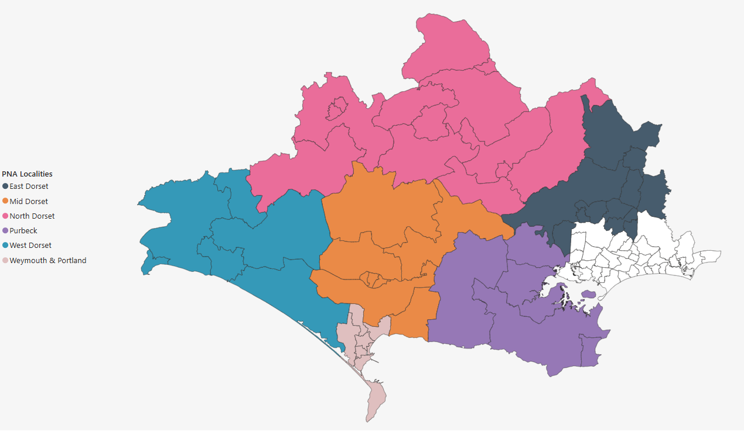

Figure 1b. BCP PNA Localities

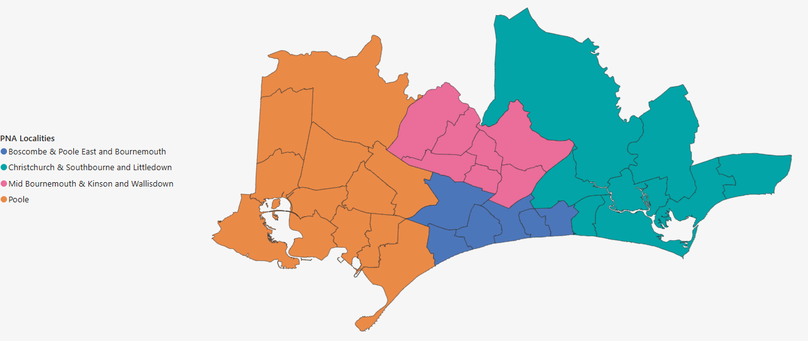

3.4 Data collation and mapping
Data from the Census, ONS population estimates, and planning information on known housing developments within the lifetime of the PNA, were collated to help identify population size and characteristics (e.g. age, ethnicity).

The Joint Strategic Needs Assessment, Dorset Intelligence and Insight Services (DIIS) data, Public Health Dorset Intelligence data, OHID public health data, ONS mortality data, and ONS mid-year estimate populations were used to identify health needs of the population of Dorset and the local areas.

Information regarding current service provision, was obtained from OHID, NHSEI and NHS Business Services Authority (NHSBSA). In addition to this, data on locally commissioned services was provided by the commissioners at Public Health Dorset and NHS Dorset. This data was uploaded into the PNA mapping tool developed by the Public Health Dorset Intelligence Team.

This mapping tool involved integrating multiple technologies to create an interactive and user-friendly web application. It was built using Python, Folium and Streamlit, the tool provides a seamless interface for users to generate isochrones based on travel time minutes, travel mode (driving, walking, cycling, and rush-hour driving), area type (rural or urban), and day type (Weekday, Saturday, or Sunday). The core functionality relies on the Mapbox API, which computes isochrones by analysing real-world travel data, factoring in road networks, traffic patterns, and mode-specific constraints. To visualize the results dynamically, the tool leverages Folium, rendering interactive maps that display the computed isochrone polygons. Users can select parameters through the Streamlit UI, which fetch and display travel-time-based accessibility areas. This tool enhances spatial analysis capabilities, enabling users to assess accessibility to pharmaceutical services to enable assessment for any gaps in the provision of services by location and opening times.

3.5 Data Limitations

Whilst every effort has been made to make the data included in this PNA accurate and timely, there are some limitations to the data that need to be considered:

- Data was collated during September 2024 – February 2025. The data provides a snapshot in time only.
- Pharmacy service data may be inaccurate. For some services, provision of the service has been used as a proxy for a pharmacy being accredited for a service. This will not give an accurate picture of service availability. For example, a pharmacy who has undergone a change in ownership will not have service delivery activity although they may now be accredited to provide the service.
- Pharmacy contracts that have undergone a change of ownership may provide a different set of services.
- Pharmacy services may not be openly commissioned. By this we mean that the commissioner may limit the number of pharmacies providing the service. Gaps in these services are created by the commissioner rather than gaps being created by lack of pharmacy provision.

3.6 Public and Pharmacy engagement
In November 2023, Healthwatch England surveyed 1,650 people across the country about their experiences with pharmacy services in England. The findings revealed that while community pharmacies are highly valued, medicine shortages and both permanent and temporary pharmacy closures continue to impact access. These closures were more prevalent in rural areas, regions with older populations, and areas with fewer GPs per head. Additionally, there is a lack of public awareness about the services offered through the Pharmacy First initiative.

In October 2024, Healthwatch Dorset conducted a public pharmacy survey to gather patient feedback for the local Pharmaceutical Needs Assessment. This survey was based on questions used by other local Healthwatch organizations and informed by the Healthwatch England survey.

The Healthwatch Dorset team collaborated with Public Health, NHS Dorset, the GP Alliance, and Community Pharmacy Dorset to promote the survey through their websites, social media, physical posters, Facebook adverts, Healthwatch eNewsletters, press releases, radio interviews, and community contacts.

The survey was launched at the end of September and ran until the end of October, collecting a total of 907 responses.

Key messages:

- 29% of respondents use an online pharmacy, with mostly positive feedback.
- People find their local pharmacy easy to access when it is within walking distance, has parking, friendly staff, and convenient opening hours.
- 38% of respondents experienced problems getting their medication. Medication shortages left people feeling helpless, frustrated, and at risk of harm.
- 7% of respondents with disabilities are not receiving the reasonable adjustments they need.
- Most respondents receive free prescriptions, but 26 people reported delaying getting their medicine due to cost or only affording medicines for some family members.
- 63% of respondents had not heard of Pharmacy First.
- Pharmacy closures and changes to opening hours are affecting access for people in rural Dorset.

3.7 Other sources of information
Information was gathered from NHS Dorset and the regional commissioning hub, the NHS Business Services Authority, Community Pharmacy Dorset, Public Health Dorset, BCP Council and Dorset Council regarding:

- Services provided to residents of Dorset HWB’s area and BCP HWB’s area, whether provided from within or outside of that area
- Known housing developments within the lifetime of the PNA and any other developments which may affect the need for pharmaceutical services

Dorset JSNA documents and the public health intelligence team provided background information on the health needs of the population.

3.8 Identifying gaps

Although the 2013 regulations require the PNA to include a statement of those pharmaceutical services that are identified as being necessary to meet the need for pharmaceutical services, there is no definition of this term within the regulations. Therefore, in developing the PNA the Steering Group considered a range of criteria that it could use to assess whether pharmaceutical services met the health needs of the population, identifying desirable improvements and optimising access.

A key challenge for Dorset is our mix of rural and urban areas, therefore accessibility was a key consideration. Although there are online services that can be accessed, our initial engagement found that most people use local services, with most driving or walking to get there. The steering group discussed the possibility of setting different travel times for urban and rural areas within BCP Council and Dorset Council. While a 15-minute walking time was considered for urban areas in BCP, the steering group ultimately decided that a 20-minute drivetime would be appropriate for both urban and rural areas.

The Steering Group also considered the issue of opening hours and how this might impact access at different times. Most prescriptions are issued in general practice. Although the GP contract specifies core hours of 8am to 6:30pm Monday to Friday, there is no requirement for the practice to be open the entire time. GP practices working together as a Primary Care Network (PCN) now provide enhanced access appointments between 6:30pm and 8pm on weekday evenings and 9am to 5pm on Saturdays, as part of the Enhanced Access Service introduced on October 1, 2022. This service aims to standardize access across the country and includes a blend of appointment modes, such as face-to-face, telephone, and digital consultations. The Steering Group considered that aligning GP opening hours with pharmacy opening hours would be beneficial. While the use of 100-hour pharmacies was initially seen as a helpful proxy, the availability of enhanced access plans now provides clearer guidance for matching service hours to patient needs. The Steering Group did not feel there was a need for 24/7 access given the times when most prescriptions are issued.

The Steering Group therefore agreed that to support ‘the identification of gaps’, for the purposes of this PNA ‘necessary services’ are defined as:

- dispensing of medicines and appliances
- the other essential services in relation to both medicines and appliances
- is accessible to the Dorset population within a 20-minute drive time

Other criteria were viewed as aids in assessment, rather than as rigid tools, and interpreted in the context of the socio-demographic and health profile of the population and consultation responses, with other services, better opening hours, and accessibility of facilities, considered as potential improvements or better access.

3.9 Equality and safety impact assessment

BCP Council and Dorset Council use equality analysis to ensure all groups can access services without disadvantage. Equality impact assessments (EIAs) are conducted when developing and reviewing policies, strategies, procedures, functions, and services. Staff complete a template with prompts to consider promoting equality and avoiding unlawful discrimination, covering the nine protected characteristics:

- Gender reassignment
- Race
- Disability
- Age
- Sex
- Sexual orientation
- Religion or belief
- Pregnancy and maternity
- Marriage and civil partnership

During the formal consultation, we will ask if any recommendations needed consideration to avoid adverse impacts on specific groups. Comments will be incorporated into a first-stage Equality Impact Assessment (EQIA) for the PNA. As the PNA has not identified any gaps, there is no need for a fuller EQIA.

3.10 Formal Consultation

X

3.11 Review and Supplementary statements

After the publication of the PNA, it will be reviewed periodically. If there are major initiatives, health requirements, or population changes that could significantly impact the assessment, the Steering Group will decide whether a revised PNA is required.

A Supplementary Statement explaining changes to the availability of pharmaceutical services may be issued instead of a revised PNA, in the following cases:

a) There has been a change to the availability of pharmaceutical services relevant to granting applications to open or relocate a pharmacy, or provide additional services;

b) The HWB is satisfied that publishing a revised PNA would be a disproportionate response or is already in the process of updating the PNA but needs a supplementary statement to prevent significant detriment to the provision of pharmaceutical services.

These Supplementary Statements will be factual and will not assess the impact of the change on the need for pharmaceutical services within an area. Once issued, a supplementary statement becomes part of the PNA.

4. Local Context

This chapter outlines the local NHS and public health organisations that have a role in community pharmacy in Dorset. It also outlines the demographics and the health needs of the local population that access these services.

4.1 Dorset Council and BCP Council

Dorset Council and Bournemouth, Christchurch and Poole (BCP) Council were created as two new unitary councils on 1 April 2019, replacing six borough and district councils, a county council, and two previous unitary councils. As unitary councils, they are responsible for a wide range of services, including social care, housing, and planning in their respective areas.

Dorset Council has around 4,500 employees serving a local population of approximately 380,000 residents. The council works closely with local communities across small rural villages, market towns, and popular coastal destinations to make Dorset a great place to live, work, and visit. Over half of the area is designated as an Area of Outstanding Natural Beauty and is home to the only natural UNESCO World Heritage Site in England, the Jurassic Coast. The council has the largest proportion of people aged over 65 of any unitary or county council in the country.

BCP Council employs more than 5,000 people and provides services to around 400,000 residents in predominantly urban areas from Hamworthy in the west to Highcliffe in the east. The council focuses on vibrant communities with an outstanding quality of life for the diverse population they serve. This includes an ageing population in the east and a younger demographic in the west. There is a large Polish and Jewish community, a variety of faith groups, and an established LGBT community. Bournemouth hosts a university and a large language school, contributing to a significant student population. The area also hosts Bourne Free, an annual festival to celebrate diversity.

4.2 Public Health Dorset

Public Health Dorset are a public health service supporting BCP Council and Dorset Council. It is a shared service across both councils that aims to help as many people as possible stay healthier for longer. This is achieved through commissioning and provision of public health services, as well as work with partners to influence the development and delivery of wider prevention work. Services commissioned or provided through Public Health Dorset include:

- Drug and Alcohol Treatment Services
- LiveWell Dorset
- NHS Health Checks
- Sexual Health Services
- Children’s public health nursing
- Community health improvement services such as weight management, smoking cessation and access to long-acting reversible contraception. Where these services are provided by community pharmacies this is covered in section 5.7.

The split of Public Health Dorset into separate teams for BCP Council and Dorset Council in April will likely lead to more localised and tailored approaches to public health services. This change will allow each council to address the specific needs of their populations, but could also introduce challenges in maintaining consistency and efficiency across shared services. Key areas such as drug and alcohol treatment, sexual health services, and community health improvement programs may see adjustments in delivery models, with each council independently managing priorities and resources to meet their unique public health goals.

4.3 NHS Dorset

NHS Dorset is the name of the NHS Dorset Integrated Care Board (ICB), established on 1 July 2022. NHS Dorset undertakes the statutory responsibilities of the former Clinical Commissioning Group (CCG) and continues to plan and meet the healthcare needs of people and communities in Dorset as an Integrated Care Board (ICB). The commissioning of primary medical care services, including GP practices and Primary Care Networks (PCNs), delegated by the NHS to the CCG, has now transitioned to the ICB. This includes initiatives to increase the number of community pharmacists within GP practices, expanding their roles in managing medicines in primary care. NHS Dorset, in collaboration with NHS England and regional commissioning hubs, is actively exploring further delegation of additional primary care services, such as Pharmaceutical Services. Delegated primary care functions are governed through a Primary Care Commissioning Committee, ensuring robust oversight and alignment with national healthcare priorities.

NHS Dorset also employs a Medicines Optimisation Team that collaborates with partners in Dorset to ensure that prescribing, dispensing, and other issues relating to medicines are addressed in a coordinated manner to meet people’s needs.

The establishment of NHS Dorset provides more opportunities for all local partners across the NHS and local authorities to work together, building and developing the existing Dorset integrated care system, Our Dorset.

4.4 Our Dorset

The Dorset Integrated Care System (ICS), known as "Our Dorset," is a partnership of Dorset Council, BCP Council, NHS services, and the community and voluntary sector. They work together to address local health, wellbeing, quality, and financial challenges across the county. The vision remains that everyone will start, live, and age well, and die with dignity, regardless of their circumstances.

Dorset became one of England’s first pilot ICSs in 2018. With changes to legislation in 2022, this way of working is now replicated across the country, providing more opportunities for local collaboration. The focus of the ICS is on removing traditional barriers between services and ensuring that people can access the support and care they need when they need it.

Each Integrated Care System has two integral parts: an Integrated Care Board (NHS Dorset) and a Health and Care Partnership established on 1 July 2022. NHS Dorset, the Integrated Care Board (ICB), the Dorset Health and Care Partnership, and the Integrated Care Partnership (ICP) make up the two parts of Our Dorset.

Figure 2. Our Dorset ICS Partners

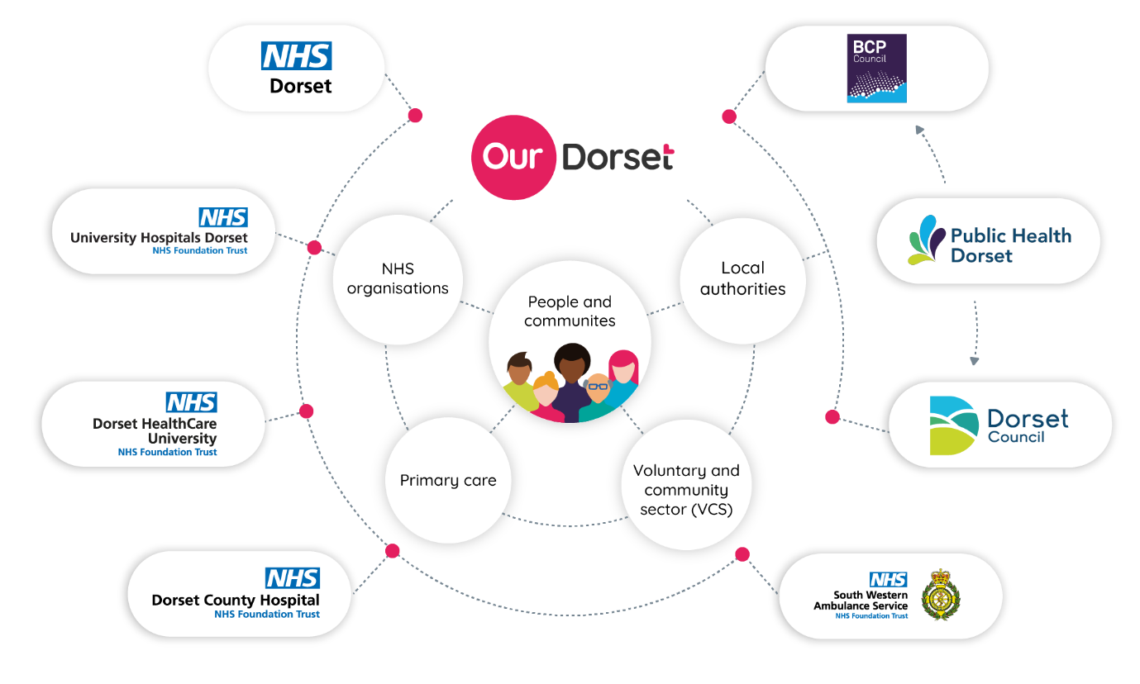

The partnership is a statutory function supporting integrated working across the county. It complements the activities of the existing Health and Wellbeing Boards by promoting integration from place level to system level. Responsibilities include:

- Addressing inequalities in health and wellbeing outcomes and ensuring better access to health services.
- Bringing together people and organisations involved in wider issues like employment, education, housing, and crime to support healthier communities.
- Improving the life chances and health outcomes of babies, children, and young people.
- Supporting communities to live more independent, healthier lives for longer.

Community pharmacies are recognized as a vital part of local communities, offering a range of services to support people's health and well-being. There is also a national and local drive to integrate pharmacy and clinical pharmaceutical skills into patient pathways through closer collaboration between PCNs and community pharmacies and expanded roles for community pharmacists in different settings.

4.5 Local Demographics

According to the Census 2021 figures, the population of BCP Council is 400,192, and the population of Dorset Council is 379,578. Both BCP Council and Dorset Council populations have a higher percentage of older persons (aged 70 plus) and a lower percentage of younger persons (aged under 20 years) than the England average. Dorset especially has a much higher older population, making up 23% of the population compared to the England average of 14%.

Changes in these population figures are shaped by both natural change (births and deaths) and by migration into and out of the area.

Figure 3. Population breakdown by 10-year age bands for England, BCP Council, and Dorset Council. ONS Census 2021

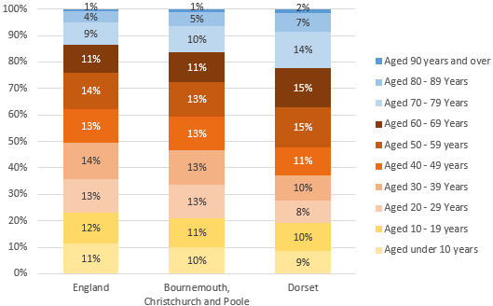

The populations of both BCP Council and Dorset Council have increased since the previous Census in 2011, BCP Council by 5.7% and Dorset Council by 4.0%. According to Office for National Statistics (ONS) mid-year population estimates data this is expected to continue with a predicted 2% population increase for BCP Council and a predicted 4% population increase for Dorset Council between 2019-2029. For both populations, growth is driven primarily by those aged 65+.

Population Forecast summary BCP Council
Over the next 3 years from 2025-28 population projections suggest the population of the BCP area overall will increase by 2,600 (0.7%). This growth is driven by increases in the population aged over 65, with the number of children and young people (aged 0-16) projected to decrease.

The number of over 65s are projected to increase by over 5,200 thousand (6%) to 2028, compared to a decrease of around 2,600 (-4%) of children and young people. The working age population is forecasts to remain roughly unchanged. By 2028 those aged 65 and over will account for 24% of the overall population.

Migration is driving population growth, with more people arriving than leaving the area. Natural change (births-deaths) is projected to reduce growth with an increasing number of deaths, due to the rise in the older population, and a fall in the number of births.

Figure 4. BCP population pyramid 2025 and 2028 compared, ONS 2018 Based sub-national population projections

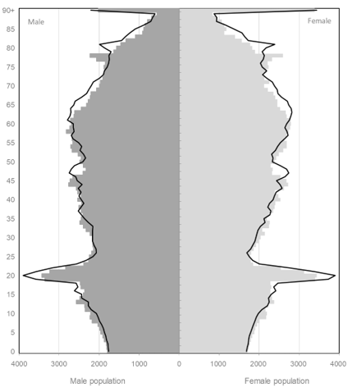

Population Forecast summary Dorset Council
Over the next 3 years from 2025-28 population projections suggest the population of Dorset overall will increase by 4,300 (1.1%). This growth is driven by increases in the population aged over 65, with the number of children and young people (aged 0-16), and working age population projected to decrease.

The number of over 65s are projected to increase by almost 8,200 thousand (7%) to 2028, compared to a decrease of around 1,900 (-3%) for children and young people aged 0-16. The working age population is forecasts to decline by just under 2,000 (-1%). By 2025 those aged 65+ will account for a third of the overall population.

Migration is driving population growth, with more people arriving than leaving the area. Natural change (births-deaths) is projected to reduce growth with an increasing number of deaths, due to the rise in the older population, and a fall in the number of births.

Figure 5. Dorset Council population pyramid 2025 and 2028 compared, ONS 2018 Based sub-national population projections

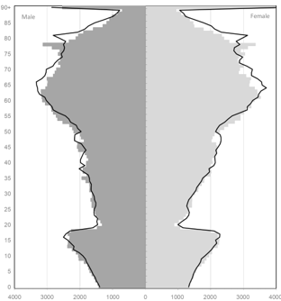

According to the 2021 Census BCP Council and Dorset Council have low levels of ethnically diverse residents with 82.4% and 93.9% respectively identifying as White British, compared to 73.5% for England and Wales. Figure 6 visualises the ethnic composition of BCP Council and Dorset Council in comparison to the England and Wales average.

The ethnic diversity of both BCP Council and Dorset Council populations have increased since the previous Census in 2011, BCP Council by 6% and Dorset Council by 1.7%.

Figure 6. Ethnicity in BCP Council, Dorset Council, and England and Wales according to the 2021 census

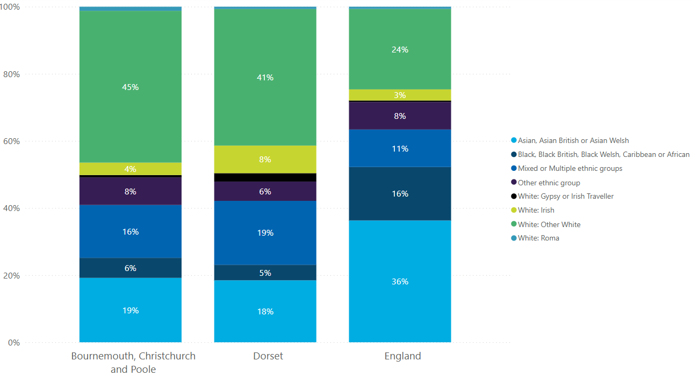

The highest proportion of BCP Council’s and Dorset Council’s ethnically diverse population are classified as 'White: Other White’ (45.2% and 40.7% respectively). This classification includes people who identify as White but who do not have UK national identity (English, Welsh Scottish, Northern Irish and British) and are also not Irish. An example would be Polish or Romanian.

Deprivation is an important factor of health and well-being for communities and individuals. Where there are higher levels of deprivation, there are consistent associations with poorer health outcomes across a range of measures that represent a major cause of inequalities in health and well-being. Figure 5 and Figure 6 visualise the most and least deprived LSOAs in their respective areas. In Dorset, there are 11 LSOAs in the most 20% deprived in the country. The Dorset Council areas of deprivation are largely located in the most urban areas, in particular Weymouth and Portland, but many of Dorset’s rural communities could also be considered deprived in terms of barriers to housing and essential services.
BCP Council has 26 LSOAs in the most 20% deprived in the country. BCP areas of deprivation are also largely located in the most urban areas, in particular areas around the town centres of Bournemouth and Poole.

Figure 7. BCP Council and deprivation

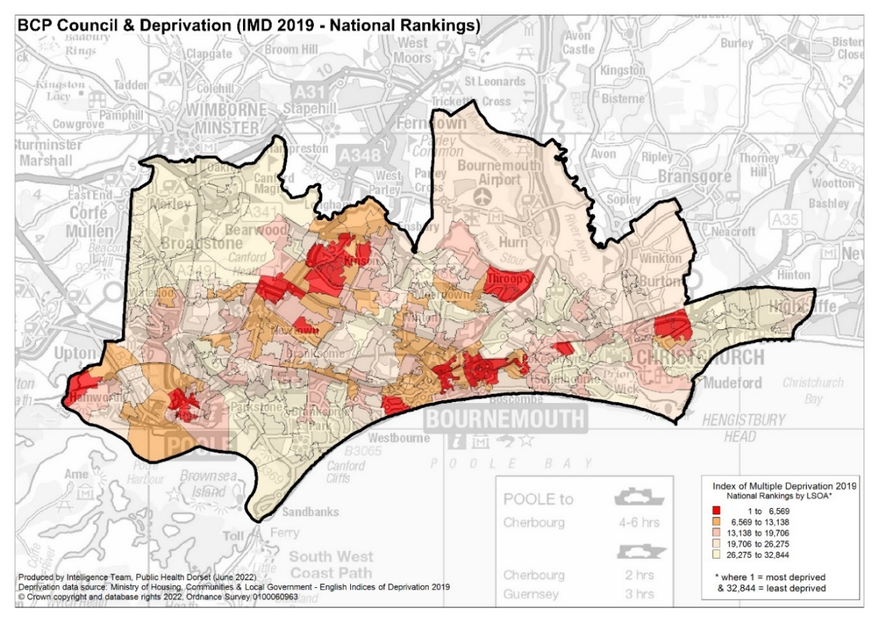

Figure 8. Dorset Council and deprivation

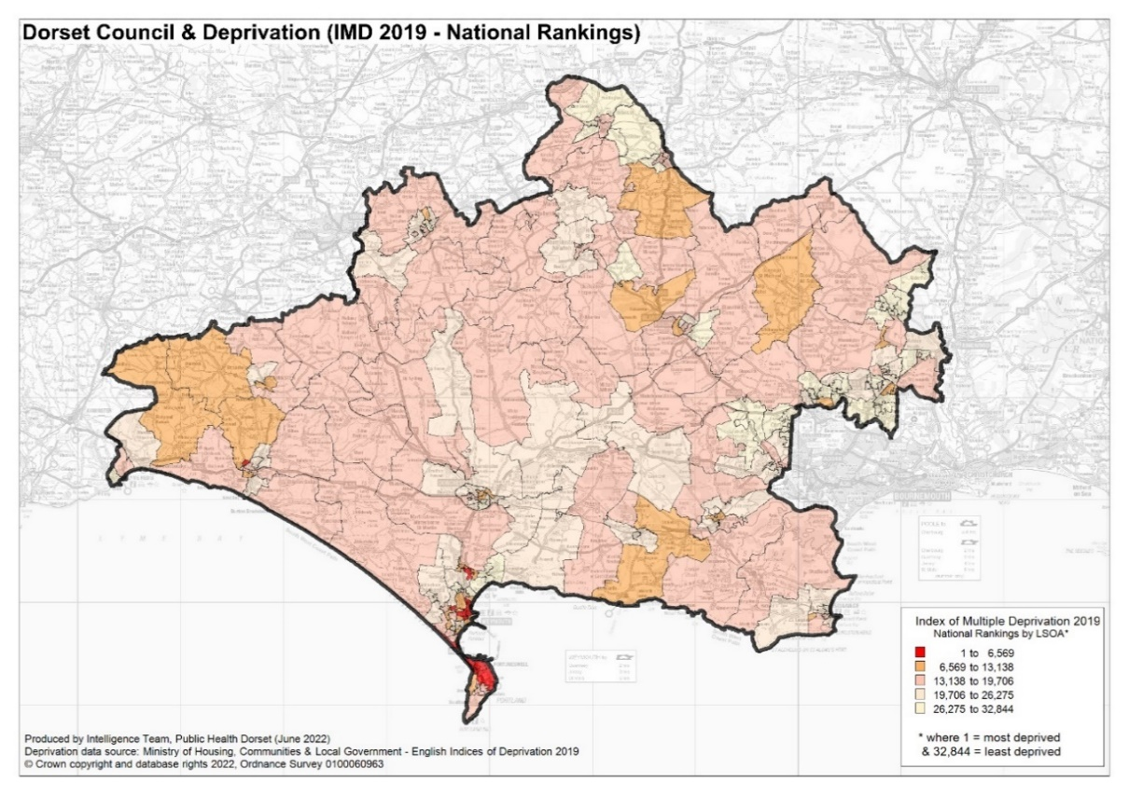

4.6 Our Dorset Joint Strategic Needs Narrative

Our Dorset Joint Strategic Needs Assessment (JSNA) is a process used to support Dorset Council and BCP Council Health and Wellbeing Boards to identify key issues and develop their Joint Health and Wellbeing Strategies in response to these.

The JSNA narratives are spilt into 3 sections

- Thriving Communities (Our population and wider determinants of health)
- Healthy Lives (Health conditions and behaviours, opportunities for prevention and early help)
- Health and Care (How services work together)

Some of the key issues around thriving communities include

- There is a social gradient in life expectancy between the most deprived and least deprived areas. In Dorset – 5.2 years for men and 4.6 years for women and in BCP – 6.9 years for men and women. Circulatory related deaths, cancer and respiratory disease are the main contributors to this inequality gap.
- The impacts of poverty, deprivation and the cost-of-living crisis. In BCP, there has been a notable increase in clients aged 65+ seeking support for a variety of issues from Citizen’s Advice services. In Dorset, 22.9% of the working age population are economically inactive – this includes people who are temporarily or long-term sick, or away from the workforce for other reasons.
- Homelessness is associated with severe poverty and poor health outcomes. There is a high demand for homelessness support - households being owed a homelessness reduction act duty is above the national average (12.6 per 1,000 in BCP, 11.7 per 1,000 in England).
- The percentage of children achieving a good level of development at 2.5 years in both Dorset and BCP is above the England average. However, there are needs around communication skills, fine motor skills and personal social skills.
- Pupil absence has increased, following national trends – around 7% of sessions were missed in the academic year due to absence. In Dorset nearly 30% of secondary school age pupils were persistently absent in 2021/22 and 28% of BCP pupils.

Some of the key issues around healthy lives include:

- Although levels of childhood obesity are better than England, around 1 in 5 Year 6 children are obese in BCP and 1 in 3 are overweight or obese in Dorset. We see variation across the Local Authorities with higher prevalence in Weymouth and Portland, Poole Town and Central Bournemouth.
- The mental health and emotional wellbeing of children – the rate of inpatient admissions for mental health conditions (Dorset 128.8 per 100,000 and BCP 143.2 per 100,000) and self-harm (Dorset 601.6 per 100,000 and BCP 706.9 per 100,000) are worse than England.
- The increasing prevalence of common mental health conditions, such as depression and anxiety.
- Social isolation and feelings of loneliness are higher among some groups such as carers, adult social care users and people with long-term health conditions.
- The percentage of adults who are overweight or obese is similar to England. However, at 65.4% of adults in Dorset and 67.1% in BCP LA this is still high and has been slowly increasing over time (2022/23).
- Smoking prevalence has been reducing in both Dorset and BCP – currently 9.1 and 10.1%. However, some vulnerable groups have much higher rates of smoking and those working in manual and routine occupations.
- Nearly 21% of adults in Dorset and 19% of adults in BCP are physically inactive – doing less than 30 minutes moderate intensity activity a week. An estimated 49% of children and young people across Dorset are not meeting recommended guidelines of 60 minutes activity per day.
- Generally, our mortality rates are in line with England - however it is important to consider variation by geography and in deaths considered preventable. We also compare poorly for some indicators relating to emergency hospital admissions for conditions like hip fractures, COPD and heart disease. There could be more opportunities to encourage prevention, early help and support people to manage their health, especially when someone has multiple long-term conditions and/or are frail.

Some of the key issues around health and care include:

- Whilst the appreciation for NHS services was evident from participants of the 100 conversations project, there was concern that healthcare services are stretched and do not have the time or capacity to listen to patients’ concerns.
- People felt that services need to work together in an integrated approach, communicate between each other to discuss patients' needs and adopt a multi-disciplinary approach.
- A need to improve sharing of patient data and medical records was also raised – sharing across multiple disciplines means that patients and carers would not have to repeat the same story.
- The need for local access to services was a key theme throughout – those with limited access to transport and travel links are adversely impacted when having to travel further distances.
- The interlink between physical and mental health is an important consideration for our services - The Kings Fund report that around 30% of people with a long-term physical health condition also experience poor mental health, for example depression or anxiety.
- Looking to the future - The 2023 Chief Medical Officer report focuses on health in an ageing society. This sets out some of the trends and health needs to consider for this population to maximise independence and minimise time spent in ill health.

Other global and national trends to consider include:

- the increasing adoption of, and demand for, personalised care
- the potential of Artificial Intelligence
- increasing mental health issues and health inequalities

4.7 Housing Growth
The population of both BCP Council and Dorset Council is growing, with most of the growth driven by those aged over 65 which is likely to impact on future healthcare demand. As such the number of homes within the area is also growing accordingly.
Sites with full planning permission and those likely to proceed within, or those that are already under construction between 2025 and 2029 inclusive come to a total of around 7,852 new homes across BCP Council and 8,831 in Dorset Council. These new homes will be built across all localities, but the largest concentrations are as detailed in Table 1. Each locality profile goes into more depth about local developments and their potential effects on the pharmaceutical service need in the area.

Table 1. BCP Council and Dorset Council significant net growth developments

Area | Development | Net dwellings
Canford and Creekmoor | Oakley Lane | 466
Canford and Creekmoor | Magna Road & Knighton Lane | 464
West Dorset | Bridport, Vearse Farm | 420
Mid Dorset | Littlemoor Urban Extension | 364
Poole West | Poole Town Centre North | 362
North Dorset | Ham Farm | 280
Bournemouth Central | Holdenhurst Road | 247
East Dorset | West Parley – Phase 1 | 238
Bournemouth Central | Exeter Road | 223

4.8 Car or Van Ownership
Census 2021 data shows that access to a car or van in the household is still less likely in more deprived localities, which are primarily located in urban areas. The overall rate of no access to a car or van for BCP Council is 21.2%, and for Dorset Council, it is 13.8%.

4.9 Identified patient groups
Not all inequality or disadvantage can be seen through a geographical lens. This is particularly relevant when examining health inequalities across different groups in society. While there may be concentrations of health inequality in the region’s low-income communities, individual factors are crucial. This section outlines patient groups who are particularly vulnerable, have specific needs that community pharmacy can help address, or impact demand on community pharmacy services.

4.9.1 Asylum seekers and refugees
There are no accurate figures on the total number of refugees or asylum seekers living in the region. The latest figures from the Migration Observatory suggest that there are approximately 1,329 asylum seekers and refugees in BCP Council and 1,243 in Dorset Council, but this may be below the true size of this community in the region, with many not receiving support or accommodation from the Home Office.

The health needs of refugees and asylum seekers are well-documented and include untreated communicable diseases, poorly controlled chronic conditions, maternity care, and mental health and specialist support needs. Additionally, a sizeable minority continue to experience physical injuries and trauma from mistreatment and torture.

Asylum seekers and refugees often face additional barriers to accessing or receiving suitable health care due to language barriers, poverty, the impact of existing trauma, or having no recourse to public funds in the UK.

4.9.2 Ethnic Minorities

The 2021 Census data shows that both BCP Council and Dorset Council have a relatively low level of diversity, ethnically diverse people representing 17.6% of the population in BCP Council, and only 6.1% of the population in Dorset Council. There are well documented links between ethnic origin and health, where people from different ethnic communities have higher levels of illness for some diseases compared to the general population. In addition, differences in cultural background, first language and residence time in a new country may impact on the access and utilisation of health care services.

4.9.3 Disabilities

Defining the specific number of individuals with some form of physical disability is problematic, due to the range and type of conditions that may be considered a ‘physical disability’. According to the 2021 Census approximately 7.3% of the population of BCP Council and 6.5% of Dorset Council reported having a limiting long-term illness or disability that limited day to day activities a lot. 10.5% of the population of BCP Council and 11.0% of Dorset Council reported having a limiting long-term illness or disability that limited day to day activities a little.

4.9.4 People with Learning Disabilities

People with learning disabilities are one of the most vulnerable groups in society. They are known to experience inequalities in health and as a result suffer poorer health outcomes compared to the general population. In March 2025, 0.6% of the Dorset GP registered populations were recorded as having a learning disability although this is likely to be an under representation as not everyone is registered.

4.9.5 Sex Workers
While there are no accurate local figures, it is estimated that there are more than 70,000 sex workers in the UK. Sex workers are at increased risk of ill-health, experiencing violence and substance misuse, and can face additional barriers in accessing health care due to fear or discrimination.

4.9.6 People who are Homeless or Sleeping Rough

According to MHCLG in 2024 there were 676 households in BCP Council and 757 households in Dorset Council either homeless or at risk of being so. Dorset Council has seen a large increase of increase of households being homeless or at risk of being so. Homeless people, especially those alone, are more at risk of complex health needs including inter-related mental health, drug misuse and alcohol dependency challenges. They are also at increased risk of injury, pneumonia, tuberculosis, dental problems, and hypothermia.

4.9.7 Gypsies, Travellers, and Roma Groups

There are six local authority-supported sites, several privately owned sites, and further unauthorized encampments that support Gypsies and Travellers. The transient nature of some of these groups can mean they sometimes experience difficulty registering with a GP practice; however, some groups are recognized to move around within the area as well as in and out of the local area.

4.9.8 Prisoners

People in prison are more likely to experience multiple, sometimes more complex physical and/or mental health conditions compared with the overall population. These issues are often further complicated by wider health determinants such as homelessness, unemployment, financial problems or insecurity, social isolation, and poor access to health services appropriate to their needs. Dorset has three prisons: Guys Marsh in Shaftesbury, and the Verne and Portland Prison on Portland. Each has a dispensary for their prison population.

4.9.9 Students

BCP Council is home to Bournemouth University, Arts University Bournemouth (AUB) and Health Services University with around 18,000 students studying at Bournemouth University, around 4,000 at AUB and 1,185 at AECC each academic year. This significantly affects the population make-up of the surrounding wards.

4.9.10 Tourists

As a popular tourist destination, Dorset sees a large number of UK and overseas visitors each year. The latest figures show there were approximately 4,162,000 trips to the area between 2017-2019. As such, some of these visitors are likely to utilize the local pharmaceutical services.

4.9.11 Military

Army camps each have their own dispensaries, using Ministry of Defence (MOD) prescriptions. There are two army camps in Dorset: Bovington Camp and Blandford Camp. Dorset has a significant military presence, with over 6,500 serving personnel across four bases.

5. Current Services

5.1 Health needs that can be met by pharmaceutical services
Community pharmacists and their teams are ideally placed to provide expertise in health advice and prevention, tackling health inequalities, supporting long-term conditions and the treatment of self-limiting common clinical conditions. As such they play an important role in meeting the health needs of the Dorset population.

The most obvious health need that can be met via pharmaceutical services is the need for appropriate drugs and appliances to be dispensed safely with expert advice available. Furthermore, the safe collection and disposal of unwanted or out of date dispensed drugs.

As well as supply medicines for the treatment of both mental and physical health problems, pharmacies can provide accessible and comprehensive information and advice to carers about what help, and support is available to them. This is part of the signposting essential service.

The specific services that are offered at pharmacies within Dorset are detailed in section 5.4 to 5.7, between them they contribute to addressing health needs in long-term conditions, sexual health, teenage pregnancy, smoking, seasonal influenza, alcohol and drug usage, palliative care, and related conditions.

Although deprivation is not such a significant issue across all of Dorset there are areas of higher deprivation. Deprivation is a key component of health inequalities; as such, appropriate accessible services on the front line of primary care, such as those provided by community pharmacy, are key to ensuring that people across all communities can have their prescriptions dispensed and benefit from a range of associated services as part of the NHS.

5.2 Number of Pharmacies and Access
There are a total of 138 contractors providing pharmaceutical services within the Dorset area (69 in BCP Council and 69 in Dorset Council). Of these:

- 132 are community pharmacies (66 in BCP Council and 66 in Dorset Council)
- 3 are distance selling pharmacies (1 in BCP Council and 2 in Dorset Council)
- 3 are dispensing appliance contractors (2 in BCP Council and 1 in Dorset Council)

The majority of community pharmacies operate 40-hour contracts. However, there are 11 100-hour pharmacies within the Dorset area (7 in BCP Council and 4 in Dorset Council), shown with blue crosses in Figure 9.

Figure 9a. 40 hour and 100-hour pharmacies across Dorset Council

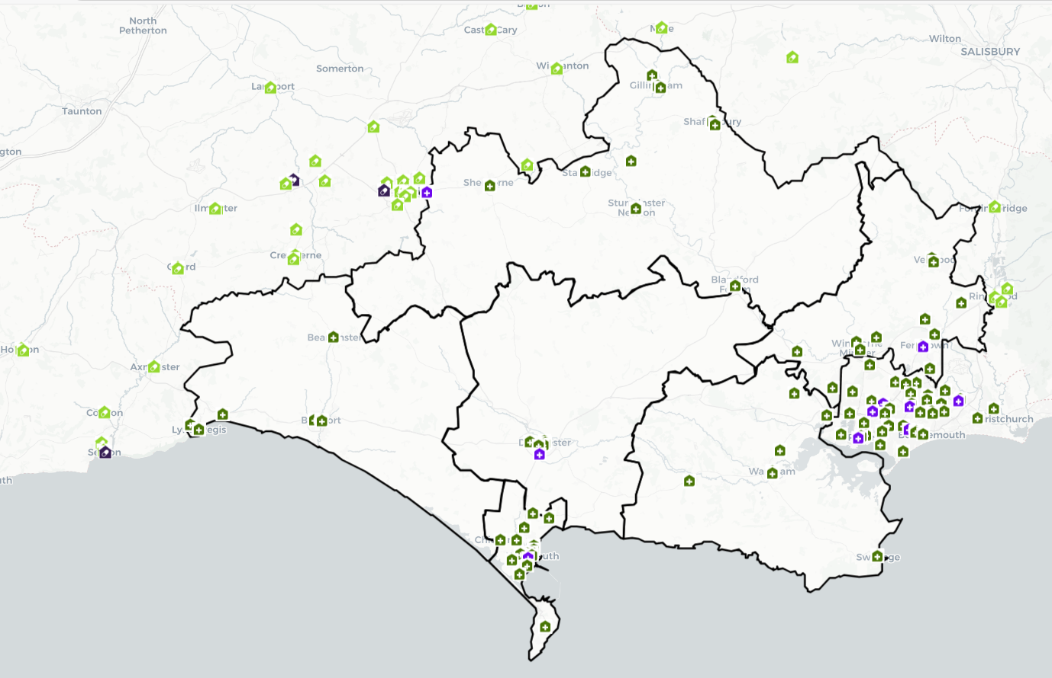

Figure 9b. 40 hour and 100-hour pharmacies across BCP
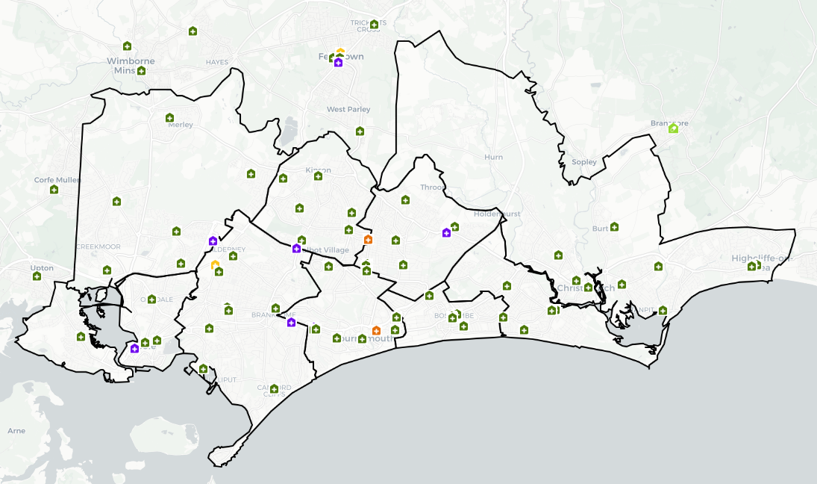

5.3 Dispensing GPs
Dispensing GP practices provide a dispensing service during their core hours from Monday to Friday excluding public and bank holidays. The service may also be provided during any extended opening hours provided by the practices.

As of January 2025, there were 16 dispensing practices across 19 sites, all in the Dorset Council area. Figure 10 displays their locations on a map.

Figure 10. Dorset pharmacies and dispensing practices
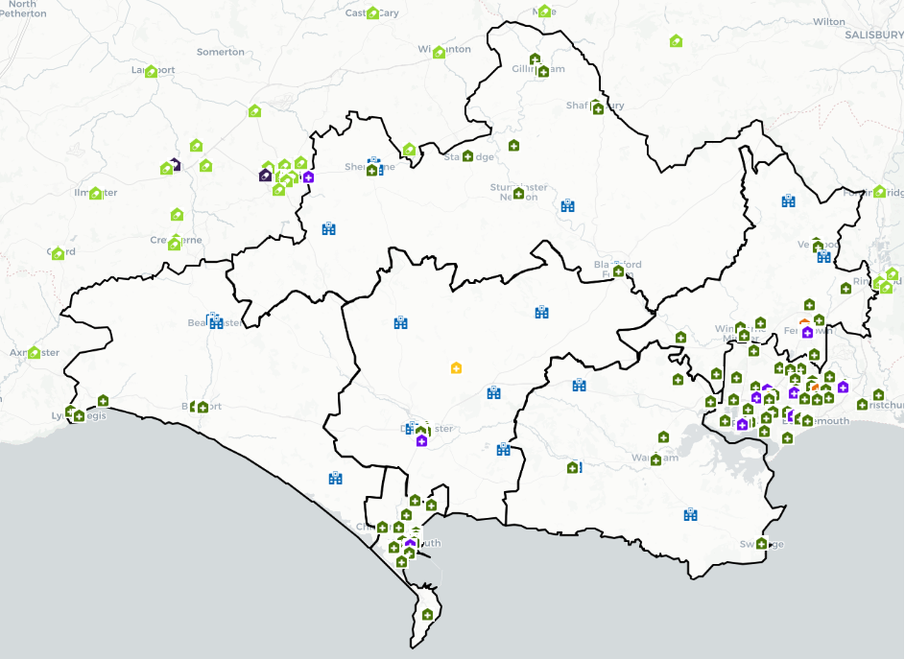

5.4 Essential Services
Essential services are provided by all community pharmacies across Dorset as detailed in 2.4.1.

5.5 Advanced Services
The advanced services provided by pharmacies across Dorset are detailed in 2.4.2. Table 2 details how many pharmacies in BCP Council and Dorset Council were signed up to deliver each of the advanced services as of April 2022. The hypertension case finding service and stop smoking service are both relatively new and pharmacies are continuing to sign up for these.

Table 2. Pharmacies signed up to deliver advanced services in Dorset

 | Pharmacy First | New Medicines Service | Flu | Hypertension case-finding service | Smoking Cessation
BCP Council | 64 | 68 | 56 | 58 | 68
Dorset Council | 65 | 67 | 57 | 61 | 67
Total | 129 | 135 | 113 | 119 | 135

 | Appliance Usage Review | Stoma Appliance Customisations | Contraception Services | Lateral Flow service
BCP Council | 3 | 9 | 53 | 48
Dorset Council | 1 | 2 | 50 | 53
Total | 4 | 11 | 103 | 101

5.6 Enhanced services
The potential enhanced services that can be commissioned are detailed in Appendix 3: Enhanced Service list and section 2.4.3. The NHS currently commissions the following enhanced service in Dorset:

- Pharmacy Urgent Repeat Medication (PURM), of which 105 pharmacies are signed up to deliver.

5.7 Locally commissioned services
Locally commissioned services are commissioned by Public Health Dorset, Dorset Council or BCP Council and include:

- Emergency Hormonal Contraception (EHC) and Chlamydia
- Describe the availability of emergency contraception, especially among young people.
- Improve access to Emergency Hormonal Contraception (EHC) and sexual health advice for women who have had unprotected sex.
- Effectively administer EHC with users and help contribute to a reduction in the number of unplanned pregnancies.
- To signpost service users who may have been at risk of Chlamydia to access online Chlamydia testing services.
- To provide free condoms to the service user as part of the consultation.
- To increase awareness of and where appropriate refer to the integrated sexual health service for service users’ contraceptive or STI needs.
- To reduce women’s repeated reliance on EHC through behaviour change interventions and effective referral for contraception.

• Needle Exchange
- Provide sterile injecting equipment
- Provide information and advice around changing lifestyles
- Provide basic information on minimising the complications associated with drug misuse
- To signpost support services for people who use alcohol or other drugs

- Supervised Consumption
- Appropriately supervise the consumption of prescribed medicines, ensuring that the dose has been administered and consumed as required by the prescription, to the patient.
- Provide direct input to promote harm reduction, including recognising people with physical health problems or severe mental health problems and signposting them to appropriate services.
- Actively encourage Service Users to access hepatitis B immunisation and to complete the course.
- Emphasise the risks of overdose, strategies to reduce those risks and to respond to overdose (including polydrug use and alcohol misuse).
- Advise on safer sex, sexual health, HBV immunisation and HBV, HCV and HIV testing.

- NHS Health Checks
- Identify people at risk of cardiovascular disease using a structured approach as part of the national NHS Health Check programme
- Support clients to take action to reduce their risk as far as possible

- Smoking Cessation
- Reduce smoking related illnesses and deaths by helping clients to give up smoking or reducing the harm caused by smoking tobacco.
- Improve the health of the population by reducing exposure to second- hand smoke, promoting smokefree homes and cars (especially cars carrying children).
- Reduce health inequalities by offering individual, flexible support through a range of delivery methods (including face to face and telephone), that is sensitive to the needs of high priority groups e.g. routine and manual workers, clients with mental health issues and/or long-term medical conditions.
- Support clients to access additional behavioural and lifestyle support by promoting or signposting to Live Well Dorset.

- Palliative care service
- The palliative care service, which supports end-of-life care by ensuring access to specific medicines urgently required to help patients remain at home if they wish, is now considered an enhanced service. This service is provided by a small number of community pharmacies in key locations, chosen based on their accessibility and, where possible, extended opening hours. Some of these pharmacies operate for 100 hours a week. With NHS Dorset now taking responsibility for commissioning primary care services, this enhanced service aligns with their broader role in ensuring equitable access to essential healthcare services across the region.

5.8 Access to pharmaceutical services on public and bank holidays
NHS Dorset, as the Integrated Care Board (ICB), has a duty to ensure that residents of the Health and Wellbeing Board’s area can access pharmaceutical services every day through its responsibility for planning and commissioning healthcare services. Pharmacies and dispensing appliance contractors are not required to open on public and bank holidays, or Easter Sunday, although some choose to do so.

The NHS and NHS Improvement asks each contractor to confirm their intentions regarding these days and where necessary will direct a contractor or contractors to open all or part of these days to ensure adequate access.

5.9 Other Services
The following services affect the need for pharmaceutical services within its area:

- Hospital pharmacies – Hospitals are increasingly adopting the Electronic Prescription Service (EPS), which enables prescriptions to be sent electronically to community pharmacies. However, rather than significantly increasing the workflow for community pharmacies, EPS is more likely to have a streamlining effect. A substantial volume of FP10s is already issued via Emergency Departments (EDs), and even if an EPS interfacing system were implemented, it is unlikely to result in a noticeable change in prescription volume for community pharmacy colleagues. That said, with the planned merger of ED departments in early 2026, some activity may shift eastwards. Currently, outpatient prescriptions are dispensed through contracts outsourced by University Hospitals Dorset NHS Foundation Trust (UHD) for Bournemouth and Poole, while Dorset County Hospital NHS Foundation Trust (DCH) manages outpatient prescriptions in-house via a wholly owned subsidiary. The implementation of EPS is expected to refine these processes and may still require adjustments to ensure seamless integration with community pharmacy services.
UHD provides acute, elective, and specialist healthcare across two main hospital sites, Bournemouth Hospital and Poole Hospital, as well as some community-based services out of Christchurch Hospital. DCH provides acute, elective, and specialist healthcare. Dorset Health Care University Foundation Trust provides community and mental health services across over 300 sites, ranging from village halls and GP surgeries to mental health inpatient hospitals and community hospitals - as well as in people's homes.
- Weymouth Hospital Urgent Treatment Centre - services at this centre will affect the need for pharmaceutical services, in particular the dispensing of prescriptions across the opening hours.
- Prison pharmacies – Where prescriptions written in prisons are dispensed in prison pharmacies the demand for the dispensing essential service may be reduced; however, in some areas, local pharmacies are used.
- Hospices - there is one hospice in Poole, the Forest Holme hospice which is part of the United Hospitals Dorset NHS Trust. There is an independent hospice in Dorchester, Weldmar Hospice, care which also provides support to people at home in the west, south and north of Dorset. These generate a very small number of prescriptions that are dispensed by community pharmacies.
- Drugs and Alcohol services support those experiencing issues with substance misuse including alcohol to improve their health, wellbeing, and employability, and includes specialist prescribing of substitution therapies for those who need it, with close links to community pharmacies. In the Dorset Council area this is provided by Reach - a partnership between EDP Drug and Alcohol Services (EDP), and Avon and Wiltshire Mental Health Partnership Trust, and in the BCP council area by We Are With You.
- Additional roles in PCNs – Increasing numbers of clinical pharmacists and pharmacy technicians are now working in Primary Care Networks with and alongside the general practice teams, taking on expanded roles which may be patient-facing or based more on technical skills and audit.
- Extended GP access – each PCN is currently developing plans to ensure that more of their patients can access routine GP appointments in the early evenings and at weekends, providing more options for those who are working. Therefore, demand for prescriptions at extended opening times may be needed.
- South Western Ambulance Services Trust (SWAST) provide emergency response.

6. Gap Analysis

The purpose of this analysis is to ascertain if there is a gap or potential future gap in the provision of community pharmacy in Dorset. Based on the necessary services definition (defined in section 3.8) the following criteria form the basis of the analysis:

- All parts of the population should have general access to a physical community pharmacy or be within range of a dispensing GP practice. Industrial and trading estates are not residential areas so will not form part of the gap analysis.
- Pharmacies located outside the borders of Dorset can qualify as providers of access if Dorset providers do not suffice in certain areas.
- In all areas the population should be within 20 minutes driving time of at least one of the above providers.
- All community pharmacies should dispense medicines and appliances and provide the other essential services in relation to both medicines and appliances.

The above criteria are considered both for the current population and the potential population as based on planned housing developments in Dorset.
Further factors that would not signify a gap in provision, but that are considered to contribute to improvements are:

- Accessibility of the service for identified patient groups.
- A choice of service providers.

6.1 Access to Pharmaceutical Services in Dorset
Nationally, a common aim is for access to a pharmacy for 99% of the population (including those living in the most deprived areas) to be possible within 20 minutes by car.

Accordingly, the Steering Group has chosen 20 minutes by car to any community pharmacy or dispensing practice. As can be seen in Figure 12, much of Dorset Council has a low population density due to how rural the area is. In Figure 11 it can be seen that although parts of BCP Council have a higher population density, the area is well supplied with pharmacies.

The 20-minute drive time is a practical and achievable distance for most people, used consistently in the 2018 and 2022 PNAs to ensure access to essential pharmaceutical services. In section 4.8 it is noted that 81% of BCP Council households and 86% of Dorset households have access to a car or van. Areas with low car ownership are near pharmacies, allowing easy access by walking, cycling, or public transport. Older residents are also conveniently located near pharmacies or have accessible transport options.

A 20-minute walk time was considered for urban areas, revealing gaps in north-east Bournemouth, north Poole, and a tourist caravan park on the west coast. These low-density areas, including the airport and industrial buildings, have good transport links and higher car ownership. The walk time covers 96% of Dorset's population over 65. Thus, a single measure was used in this report.

Responses to the Healthwatch questionnaire provide the following insights into accessing pharmacies.
- 98% had used a local pharmacy in the past 12 months
- 67% find access to their preferred pharmacy very easy or easy
- People responded they find their local pharmacy easy to access when it’s within walking distance or has parking, has friendly staff and when it’s opening hours suit them.

Figure 11. BCP Council pharmacies by population density
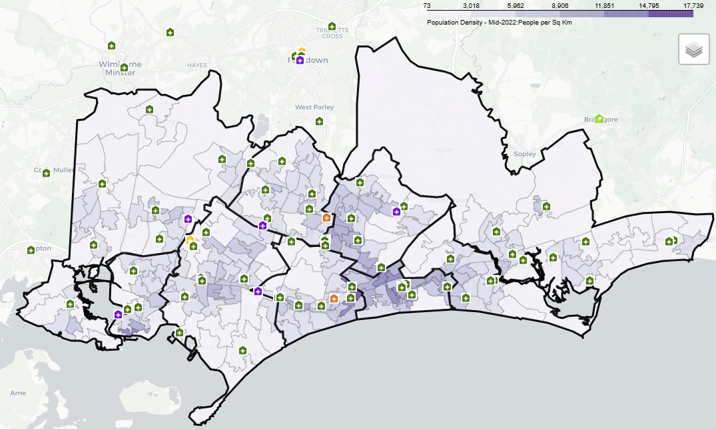

Figure 12. Dorset Council pharmacies by population density

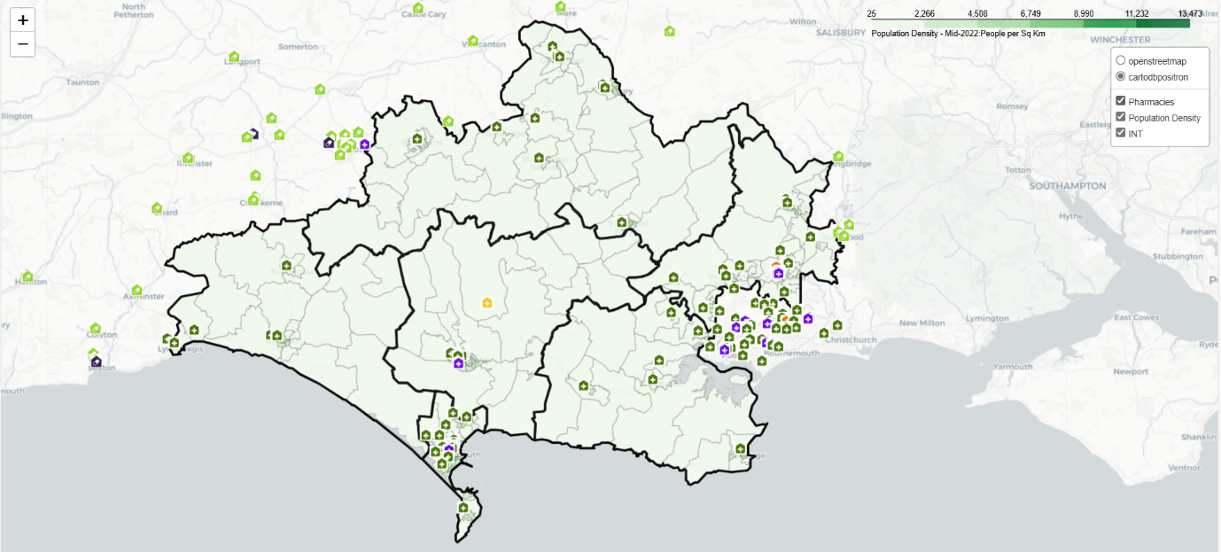

Figure 13 shows that residents within BCP would be able to access a pharmacy within a 20-minute drive time. Neighbourhood Areas such as Kinson & Wallisdown, Boscombe and Poole West where the most deprived areas are situated, there is a very high proportion of residents living within a 20-minute drive of a pharmacy.

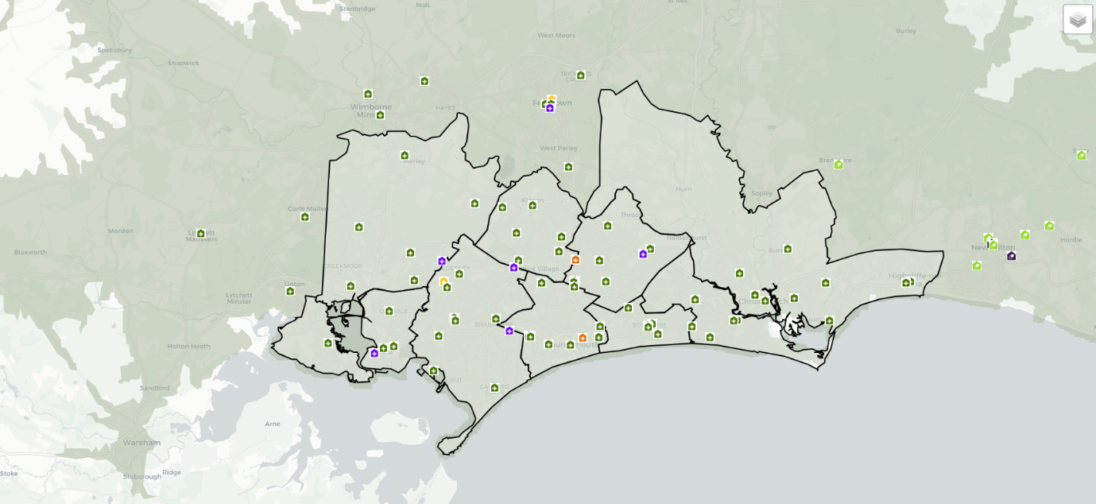

Mapping 20-minute drive times in Dorset show that no location is more than a 20-minute drive from a pharmacy during a weekday during the day. The GP practices in these areas are dispensing practices and all the patients in these very rural areas are eligible to access dispensing services from these practices; once these are included, all residents can access appropriate provision within a 20-minute drive time. This is mapped in Figure 14.

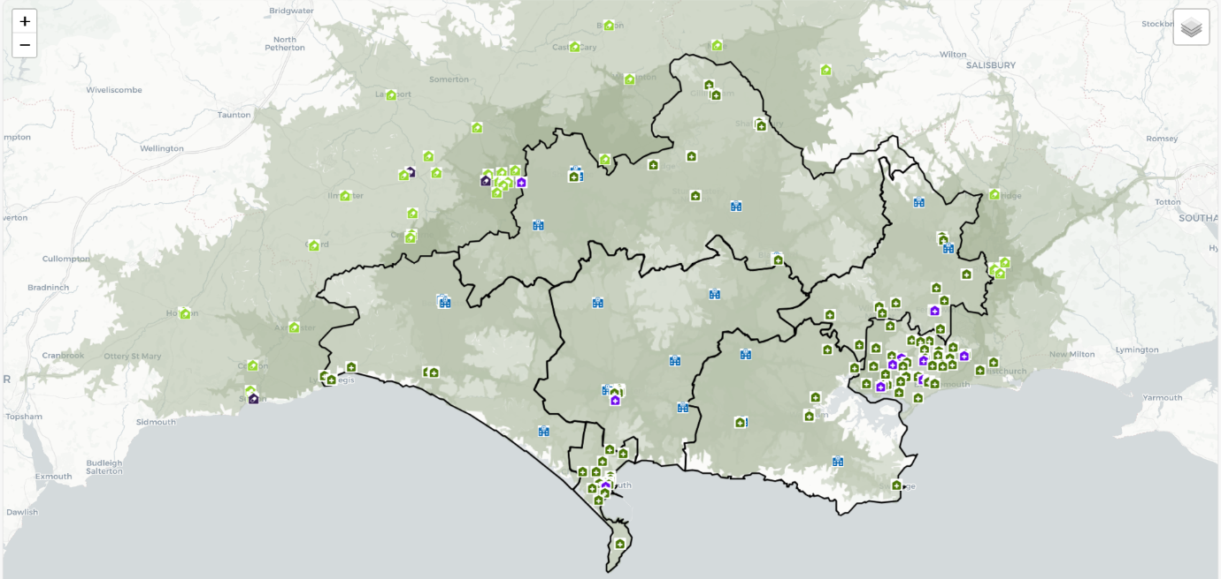

According to this analysis, the current population of Dorset can access a physical community pharmacy or is within range of a dispensing GP practice as set out in the criteria at the start of this chapter, as such no gaps have been identified.

6.2 Opening Hours
Detailed opening times of all pharmacy contractors in Dorset are shown in Appendix 7: List of community pharmacies and opening times. Earliest opening times and latest closing times are recorded for each Neighbourhood Area in the locality profiles.

In summary there are 122 40-hour community pharmacies and 10 100-hour community pharmacies in Dorset. There are 3 DACs and 3 distance-selling pharmacies that also operate a minimum of 40 hours.

There is at least one pharmacy in every locality open until at least 6:30 p.m. on weekdays, except in Dorset West PNA, where the pharmacy closes at 6 p.m. Additionally, every locality has at least one pharmacy open on Saturdays, and most localities also have at least one pharmacy open on Sundays.

Pharmaceutical services in the out-of-hours period are principally supported by 100-hour pharmacies. It is worth noting that, in practice, these 100-hour pharmacies may have applied to reduce their core opening hours to between 72 and 100 hours. Together, the current 100-hour contract pharmacies offer the local population good access to pharmaceutical services during evenings, weekends and bank holidays. Drive times shown in Figure 13 may be optimistic in periods of heavy traffic but are realistic late at night and on Sundays when the services would be required.

Regarding opening hours across Dorset, all localities have good provision during office hours, and at least provision until 6:30 p.m. on an evening and during Saturday daytimes. As it stands, no gaps in provision have been identified.

6.3 Choice of service provision
Patients can choose where they access pharmaceutical services; this may be close to their GP practice, their home, their place of work or where they go for shopping, recreational or other reasons. As a result, some of the prescriptions written for Dorset registered patients are dispensed outside the area.

Generally, the demand for pharmaceutical services by the population registered to GP practices within Dorset is met by pharmacies from within the two HWB areas, with pharmacies outside of the Dorset area providing a small amount of dispensing, likely due to ease of access. These include pharmacies in the neighbouring local authorities Somerset, Wiltshire, Hampshire and Devon.

According to the Healthwatch survey, 71% of responders preferred to access their pharmacy in-person, and 5% preferred online access solely. The remaining people used a combination of methods. Fewer than 12% of responders stated it was difficult or very difficult to access their preferred pharmacy.

Distance-selling pharmacies made up around 2% of dispenses between April to October 2024. There are two distance selling pharmacies within Dorset, and a further 407 nationally, any one of which residents can choose to use.

DACs are specialist services for the dispensing of medical appliances of which there are three in Dorset, and many others operating nationally that Dorset residents can access.

In summary the choice of pharmaceutical services in Dorset is reasonable. The population of Dorset access pharmacies in different ways. Typically, in the rural areas, people will access a range of services through their local GP and pharmacies in their local market town. In addition, supermarket or out-of-town retail areas offer other ways of accessing pharmaceutical services. In the urban areas of Bournemouth and Poole, the population have a greater choice of pharmacies. Changing technology also offers access to internet pharmacy services, which may be based anywhere in the UK. Therefore, the level of choice available in Dorset meets the appropriate criteria and no gaps have been identified.

6.4 Meeting the needs of specific populations
Section 4.9 identifies vulnerable groups and communities that may have specific health needs that should be recognised by community pharmacy in Dorset. As well as an awareness of these populations and their health needs, there are services and facilities that can be put in place to ensure their needs are met.

First and foremost, all pharmacies are required to be compliant with the Equalities Act. This legislates against direct discrimination against any person for the supply of goods or services. Pharmacy contractors are required to make reasonable adjustments to accommodate any person with a disability both on their premises and in terms of service, for example, wheelchair access and ramps. Wherever possible, provision of disabled-friendly services (wheelchair accessible consulting rooms, provision for those with visual or hearing difficulties, etc.) should be considered an important aspect of good service provision.

Considering the number of residents who are from an ethnic minority (section 4.5), the number of those unable to speak English are likely to be small; however, where this occurs it creates a barrier to access. Community pharmacies in Dorset must be able to signpost people to language access services. All pharmacies in Dorset can utilize the NHS interpretation and translation services, although in the past not all pharmacies were aware of how or where to access help with translation in such situations. NHSE have clarified that services can access help through the NHS local office when required, however this can take time to arrange and may not be immediately available. Working with language interpreters and translators helps provide optimal patient care as it can reduce communication barriers between practitioner and patient. It has been shown to improve safety with respect to diagnosis and prescription.

Homeless people can register with a General Practice and then access community pharmacies for dispensing medication. In addition, anybody who is homeless can also access advice and support from a community pharmacy without GP registration or the need to provide an address.

6.5 Community pharmacy workforce
The community pharmacy workforce was not one of the criteria considered by the gap analysis. We know that there have been difficulties in community pharmacy recruitment in Dorset for some years, which has been highlighted further with the development of additional and expanded roles for pharmacists and technicians. The issue also came through very strongly in the community engagement survey and in the formal consultation.

Pharmacy leaders in Dorset continue to face workforce shortages, with vacancy rates rising—pharmacist vacancies have increased from 7% in 2021 to 18% in 2023, and technician vacancies persist. While various initiatives have been in place since 2019, measurable improvements have only recently emerged. The number of trainee pharmacists has increased, with multisector placements rising from 20% (2024/25) to 56% (2025/26), and funding has expanded integrated Pre-registration Trainee Pharmacy Technician (PTPT) training across multiple sectors. Workforce development remains a priority for the Dorset Pharmacy Workforce Faculty, which supports collaboration across organizations. Local teams continue to work closely with workforce leads, the Dorset People Committee, and previously with NHS England to secure funding and enhance workforce development, with a growing focus on recruitment and retention strategies to sustain the local pharmacy workforce.

The Our Dorset Pharmacy Workforce Faculty Review (January 2025) highlights key areas requiring further attention. Expanding independent prescribing training for community pharmacists is essential to support primary care recovery, though this will require increased supervision capacity. Cross-sector partnerships have grown significantly, strengthening workforce pipelines and improving community pharmacy recruitment. Funding has also supported integrated PTPT training across multiple sectors, alongside additional financial support for pharmacy technician apprenticeships.

Despite these efforts, workforce vacancies remain a concern. In the NHS-managed sector, the most significant gaps are in junior pharmacist and senior pharmacy technician roles. In community pharmacy, pharmacist vacancies have risen sharply, and technician vacancies persist. While trainee pharmacist numbers have improved, further efforts are needed. Primary care must also focus on joint recruitment of trainee pharmacists and PTPTs within PCNs to support system-wide sustainability. Additionally, the creation of more Band 6 roles is crucial to retaining newly qualified pharmacists within Dorset.

7. Conclusion

Throughout this PNA the provision of pharmaceutical services across Dorset has been considered in conjunction with the demography and health needs of the population. Analysis has been conducted as to whether the current provision meets the needs of the population, both as a whole and at a locality level (see individual locality profiles), and whether there are any potential gaps in pharmaceutical service provision either now or within the lifetime of the document.

Considering the range of information considered within this needs assessment, including current provision of services across the area, the results of the public survey, and the formal consultation it can be concluded that there is appropriate provision of pharmaceutical services in Dorset.

The anticipated increase in housing developments in each locality area over the next three-year period until 2025 will not have a significant impact on the overall provision of pharmaceutical services and at present it is not anticipated that additional pharmacy facilities will be required.

7.1 BCP Council necessary services – current provision
For this PNA, the Steering Group has agreed that necessary services are:

- dispensing of medicines and appliances
- the other essential services in relation to both medicines and appliances
- is accessible to the Dorset population within a 20-minute drive time

Based on the information available at the time of developing this PNA no current gaps in the provision of necessary services have been identified in any of the localities across BCP Council.

7.2 BCP Council necessary services – future provision
Based on the information available at the time of developing this PNA no gaps in the need for the necessary services in specified future circumstances have been identified in any of the localities across BCP Council.

7.3 BCP Council other relevant services - current provision
For the purposes of this pharmaceutical needs assessment, the Steering Group has agreed that other relevant services are the locally commissioned advanced and enhanced services.

Based on the information available at the time of developing this PNA no gaps in the current provision of other relevant services or in specified future circumstances have been identified in any of the localities across BCP Council.

7.4 BCP Council improvements and better access – gaps in provision
Based on the information available at the time of developing this PNA no gaps have been identified in essential services, advanced services, or enhanced services that if provided either now or in the future would secure improvements, or better access, to essential services in any of the localities. Future improvements and better access are best managed through working with existing contractors and improving integration with other services and within local area service rather than through the opening of additional pharmacies.

7.5 Dorset Council necessary services – current provision
For this PNA, the Steering Group has agreed that necessary services are:

- dispensing of medicines and appliances
- the other essential services in relation to both medicines and appliances
- is accessible to the Dorset population within a 20-minute drive time

Based on the information available at the time of developing this PNA no current gaps in the provision of necessary services have been identified in any of the localities across Dorset Council.

7.6 Dorset Council necessary services – future provision
Based on the information available at the time of developing this PNA no gaps in the need for the necessary services in specified future circumstances have been identified in any of the localities across Dorset Council.

7.7 Dorset Council other relevant services - current provision
For the purposes of this pharmaceutical needs assessment, the Steering Group has agreed that other relevant services are the locally commissioned advanced and enhanced services.

Based on the information available at the time of developing this PNA no gaps in the current provision of other relevant services or in specified future circumstances have been identified in any of the localities across Dorset Council.

7.8 Dorset Council improvements and better access – gaps in provision
Based on the information available at the time of developing this PNA, future improvements and better access are best managed through working with existing contractors and improving integration with other services and within Primary Care Networks rather than through the opening of additional pharmacies.

No other gaps have been identified in essential services, advanced services, or enhanced services that if provided either now or in the future would secure improvements, or better access, to essential services in any of the localities.

7.9 Our Dorset – local recommendations

X

8. Appendices

Appendix 1: Acronyms and definitions

A&E Accident and Emergency
AUR Appliance Use Review
BCP Bournemouth, Christchurch and Poole
CCG Clinical Commissioning Group
COPD Chronic Obstructive Pulmonary Disease
DAC Dispensing Appliance Contractor
DRUM Dispensing review of the use of medicines
DSP Distance-Selling Pharmacy
DSQS Dispensary Services Quality Scheme
EHC Emergency hormonal contraception
EIA Equality impact assessment
EPS Electronic Prescription Service
HIV Human immunodeficiency virus
HWB Health and Wellbeing Board
ICB Integrated Care Board
ICS Integrated Care System
JSNA Joint Strategic Needs Assessment
LGBT Lesbian, gay, bisexual and transgender
LPS Local Pharmaceutical Services
LSOA Lower layer super output area
NMS New medicine service
NUMSAS NHS Urgent Medicine Supply Advanced Service
ONS Office for National Statistics
PCSE Primary Care Support England
PNA Pharmaceutical Needs Assessment
STI Sexually transmitted infections
UK United Kingdom

Appendix 2: Legislation relating to PNAs

Section 128A of the NHS Act 2006, as amended by the Health and Social Care Act 2012, sets out the requirements for HWBs to develop and update PNAs and gives the Department of Health powers to make regulations.

Section 128A Pharmaceutical needs assessments

(1) Each Health and Well-being Board must in accordance with regulations--
(a) assess needs for pharmaceutical services in its area, and
(b) publish a statement of its first assessment and of any revised assessment.

(2) The regulations must make provision--
(a) as to information which must be contained in a statement;
(b) as to the extent to which an assessment must take account of likely future needs;
(c) specifying the date by which a Health and Well-being Board must publish the statement of its first assessment;
(d) as to the circumstances in which a Health and Well-being Board must make a new assessment.

(3) The regulations may in particular make provision--
(a) as to the pharmaceutical services to which an assessment must relate;
(b) requiring a Health and Well-being Board to consult specified persons about specified matters when making an assessment;
(c) as to the manner in which an assessment is to be made;
(d) as to matters to which a Health and Well-being Board must have regard when making an assessment.

The regulations referred to are the NHS (Pharmaceutical and Local Pharmaceutical Services) Regulations 2013, as amended, in particular Part 2 and Schedule 1.
Part 2: Pharmaceutical needs assessments

3. Pharmaceutical needs assessments

(1) The statement of the needs for pharmaceutical services which each HWB is required to publish by virtue of section 128A of the 2006 Act(1) (pharmaceutical needs assessments), whether it is the statement of its first assessment or of any revised assessment, is referred to in these Regulations as a “pharmaceutical needs assessment”.

(2) The pharmaceutical services to which each pharmaceutical needs assessment must relate are all the pharmaceutical services that may be provided under arrangements made by the NHSCB for—
(a) the provision of pharmaceutical services (including directed services) by a person on a pharmaceutical list;
(b) the provision of local pharmaceutical services under an LPS scheme (but not LP services which are not local pharmaceutical services); or
(c) the dispensing of drugs and appliances by a person on a dispensing doctors list (but not other NHS services that may be provided under arrangements made by the NHSCB with a dispensing doctor).

4. Information to be contained in pharmaceutical needs assessments

(1) Each pharmaceutical needs assessment must contain the information set out in Schedule 1.

(2) Each HWB must, in so far as is practicable, keep up to date the map which it includes in its pharmaceutical needs assessment pursuant to paragraph 7 of Schedule 1 (without needing to republish the whole of the assessment or publish a supplementary statement).

5. Date by which the first HWB pharmaceutical needs assessments are to be published
Each HWB must publish its first pharmaceutical needs assessment by 1st April 2015.

6. Subsequent assessments

(1) After it has published its first pharmaceutical needs assessment, each HWB must publish a statement of its revised assessment within 3 years of its previous publication of a pharmaceutical needs assessment.

(2) A HWB must make a revised assessment as soon as is reasonably practicable after identifying changes since the previous assessment, which are of a significant extent, to the need for pharmaceutical services in its area, having regard in particular to changes to—
(a) the number of people in its area who require pharmaceutical services;
(b) the demography of its area; and
(c) the risks to the health or well-being of people in its area,
unless it is satisfied that making a revised assessment would be a disproportionate response to those changes.

(3) Pending the publication of a statement of a revised assessment, a HWB may publish a supplementary statement explaining changes to the availability of pharmaceutical services since the publication of its or a Primary Care Trust’s pharmaceutical needs assessment (and any such supplementary statement becomes part of that assessment), where—
(a) the changes are relevant to the granting of applications referred to in section 129(2)(c)(i) or (ii) of the 2006 Act; and
(b) the HWB—
(i) is satisfied that making its first or a revised assessment would be a disproportionate response to those changes, or
(ii) is in the course of making its first or a revised assessment and is satisfied that immediate modification of its pharmaceutical needs assessment is essential in order to prevent significant detriment to the provision of pharmaceutical services in its area.

(4) Where chemist premises are removed from a pharmaceutical list as a consequence of the grant of a consolidation application, if in the opinion of the relevant HWB the removal does not create a gap in pharmaceutical services provision that could be met by a routine application—
(a) to meet a current or future need for pharmaceutical services; or
(b) to secure improvements, or better access, to pharmaceutical services,
the relevant HWB must publish a supplementary statement explaining that, in its view, the removal does not create such a gap, and any such statement becomes part of its pharmaceutical needs assessment

7. Temporary extension of Primary Care Trust pharmaceutical needs assessments and access by the NHSCB and HWBs to pharmaceutical needs assessments

(1) Before the publication by an HWB of the first pharmaceutical needs assessment that it prepares for its area, the pharmaceutical needs assessment that relates to any locality within that area is the pharmaceutical needs assessment that relates to that locality of the Primary Care Trust for that locality immediately before the appointed day, read with—
(a) any supplementary statement relating to that assessment published by a Primary Care Trust under the 2005 Regulations or the 2012 Regulations; or
(b) any supplementary statement relating to that assessment published by the HWB under regulation 6(3).

(2) Each HWB must ensure that the NHSCB has access to—
(a) the HWB’s pharmaceutical needs assessment (including any supplementary statement that it publishes, in accordance with regulation 6(3), that becomes part of that assessment);
(b) any supplementary statement that the HWB publishes, in accordance with regulation 6(3), in relation to a Primary Care Trust’s pharmaceutical needs assessment; and
(c) any pharmaceutical needs assessment of a Primary Care Trust that it holds,
which is sufficient to enable the NHSCB to carry out its functions under these Regulations.

(3) Each HWB must ensure that, as necessary, other HWBs have access to any pharmaceutical needs assessment of a Primary Care Trust that it holds, which is sufficient to enable the other HWBs to carry out their functions under these Regulations.

8. Consultation on pharmaceutical needs assessments

(1) When making an assessment for the purposes of publishing a pharmaceutical needs assessment, each HWB (HWB1) must consult the following about the contents of the assessment it is making—
(a) any Local Pharmaceutical Committee for its area (including any Local Pharmaceutical Committee for part of its area or for its area and that of all or part of the area of one or more other HWBs);
(b) any Local Medical Committee for its area (including any Local Medical Committee for part of its area or for its area and that of all or part of the area of one or more other HWBs);
(c) any persons on the pharmaceutical lists and any dispensing doctors list for its area;
(d) any LPS chemist in its area with whom the NHSCB has made arrangements for the provision of any local pharmaceutical services;
(e) any Local Healthwatch organisation for its area, and any other patient, consumer or community group in its area which in the opinion of HWB1 has an interest in the provision of pharmaceutical services in its area; and
(f) any NHS trust or NHS foundation trust in its area;
(g) the NHSCB; and
(h) any neighbouring HWB.

(2) The persons mentioned in paragraph (1) must together be consulted at least once during the process of making the assessment on a draft of the proposed pharmaceutical needs assessment.

(3) Where a HWB is consulted on a draft under paragraph (2), if there is a Local Pharmaceutical Committee or Local Medical Committee for its area or part of its area that is different to a Local Pharmaceutical Committee or Local Medical Committee consulted under paragraph (1)(a) or (b), that HWB—
(a) must consult that Committee before making its response to the consultation; and
(b) must have regard to any representations received from the Committee when making its response to the consultation.

(4) The persons consulted on the draft under paragraph (2) must be given a minimum period of 60 days for making their response to the consultation, beginning with the day by which all those persons have been served with the draft.

(5) For the purposes of paragraph (4), a person is to be treated as served with a draft if that person is notified by HWB1 of the address of a website on which the draft is available and is to remain available (except due to accident or unforeseen circumstances) throughout the period for making responses to the consultation.

(6) If a person consulted on a draft under paragraph (2)—
(a) is treated as served with the draft by virtue of paragraph (5); or
(b) has been served with copy of the draft in an electronic form,
but requests a copy of the draft in hard copy form, HWB1 must as soon as is practicable and in any event within 14 days supply a hard copy of the draft to that person (free of charge).

9. Matters for consideration when making assessments

(1) When making an assessment for the purposes of publishing a pharmaceutical needs assessment, each HWB must have regard, in so far as it is practicable to do so, to the following matters—
(a) the demography of its area;
(b) whether in its area there is sufficient choice with regard to obtaining pharmaceutical services;
(c) any different needs of different localities within its area;
(d) the pharmaceutical services provided in the area of any neighbouring HWB which affect—
(i) the need for pharmaceutical services in its area, or
(ii) whether further provision of pharmaceutical services in its area would secure improvements, or better access, to pharmaceutical services, or pharmaceutical services of a specified type, in its area; and
(e) any other NHS services provided in or outside its area (which are not covered by sub-paragraph (d)) which affect—
(i) the need for pharmaceutical services in its area, or
(ii) whether further provision of pharmaceutical services in its area would secure improvements, or better access, to pharmaceutical services, or pharmaceutical services of a specified type, in its area.

(2) When making an assessment for the purposes of publishing a pharmaceutical needs assessment, each HWB must take account of likely future needs—
(a) to the extent necessary to make a proper assessment of the matters mentioned in paragraphs 2 and 4 of Schedule 1; and
(b) having regard to likely changes to—
(i) the number of people in its area who require pharmaceutical services,
(ii) the demography of its area, and
(iii) the risks to the health or well-being of people in its area.

Schedule 1: Information to be contained in pharmaceutical needs assessments

1. Necessary services: current provision
A statement of the pharmaceutical services that the HWB has identified as services that are provided—
(a) in the area of the HWB and which are necessary to meet the need for pharmaceutical services in its area; and
(b) outside the area of the HWB but which nevertheless contribute towards meeting the need for pharmaceutical services in its area (if the HWB has identified such services).

2. Necessary services: gaps in provision
A statement of the pharmaceutical services that the HWB has identified (if it has) as services that are not provided in the area of the HWB but which the HWB is satisfied—
(a) need to be provided (whether or not they are located in the area of the HWB) in order to meet a current need for pharmaceutical services, or pharmaceutical services of a specified type, in its area;
(b) will, in specified future circumstances, need to be provided (whether or not they are located in the area of the HWB) in order to meet a future need for pharmaceutical services, or pharmaceutical services of a specified type, in its area.

3. Other relevant services: current provision
A statement of the pharmaceutical services that the HWB has identified (if it has) as services that are provided—
(a) in the area of the HWB and which, although they are not necessary to meet the need for pharmaceutical services in its area, nevertheless have secured improvements, or better access, to pharmaceutical services in its area;
(b) outside the area of the HWB and which, although they do not contribute towards meeting the need for pharmaceutical services in its area, nevertheless have secured improvements, or better access, to pharmaceutical services in its area;
(c) in or outside the area of the HWB and, whilst not being services of the types described in sub-paragraph (a) or (b), or paragraph 1, they nevertheless affect the assessment by the HWB of the need for pharmaceutical services in its area.

4. Improvements and better access: gaps in provision
A statement of the pharmaceutical services that the HWB has identified (if it has) as services that are not provided in the area of the HWB but which the HWB is satisfied—
(a) would, if they were provided (whether or not they were located in the area of the HWB), secure improvements, or better access, to pharmaceutical services, or pharmaceutical services of a specified type, in its area,
(b) would, if in specified future circumstances they were provided (whether or not they were located in the area of the HWB), secure future improvements, or better access, to pharmaceutical services, or pharmaceutical services of a specified type, in its area.

5. Other NHS services
A statement of any NHS services provided or arranged by a local authority, the NHSCB, a CCG, an NHS trust or an NHS foundation trust to which the HWB has had regard in its assessment, which affect—
(a) the need for pharmaceutical services, or pharmaceutical services of a specified type, in its area; or
(b) whether further provision of pharmaceutical services in its area would secure improvements, or better access, to pharmaceutical services, or pharmaceutical services of a specified type, in its area.

6. How the assessment was carried out
An explanation of how the assessment has been carried out, and in particular—
(a) how it has determined what are the localities in its area;
(b) how it has taken into account (where applicable)—
(i) the different needs of different localities in its area, and
(ii) the different needs of people in its area who share a protected characteristic; and
(c) a report on the consultation that it has undertaken.

7. Map of provision
A map that identifies the premises at which pharmaceutical services are provided in the area of the HWB.

Finally, specifically in relation to controlled localities, regulation 39 provides:
39. Process of determining controlled localities: formulation of the NHSCB’s decision
…
(2) Once it has determined whether or not an area is or is part of a controlled locality, the NHSCB must—
(a) if it determines that the area is to become or become part of a controlled locality, or is to cease to be part of a controlled locality—
(i) delineate precisely the boundary of the resulting controlled locality on a map,
(ii) publish that map, and
(iii) make that map available as soon as is practicable to any HWB that has all or part of that controlled locality in its area;
…
(4) A HWB to which a map is made available under paragraph (2)(a)(iii) must—
(a) publish that map alongside its pharmaceutical needs assessment map (once it has one); or
(b) include the boundary of the controlled locality (in so far as it is in, or part of the boundary of, the HWB’s area) in its pharmaceutical needs assessment map (once it has one).

Appendix 3: Enhanced Service list (2025)

- Antiviral collection service
- Anticoagulation monitoring
- Care home service
- Disease-specific medicines management service
- Emergency supply service
- Gluten-free food supply service
- Home delivery service
- Independent prescribing service
- Language access service
- Medication review service
- Medicines assessment and compliance support service
- Minor ailment scheme
- Needle and syringe exchange
- Patient group direction service
- Prescriber support service
- Schools service
- Screening service
- Stop smoking service
- Supervised administration service
- Supplementary prescribing service
- COVID-19 vaccination service (added as a National Enhanced Service)

Appendix 4: Maps of PNA localities

Dorset East PNA locality

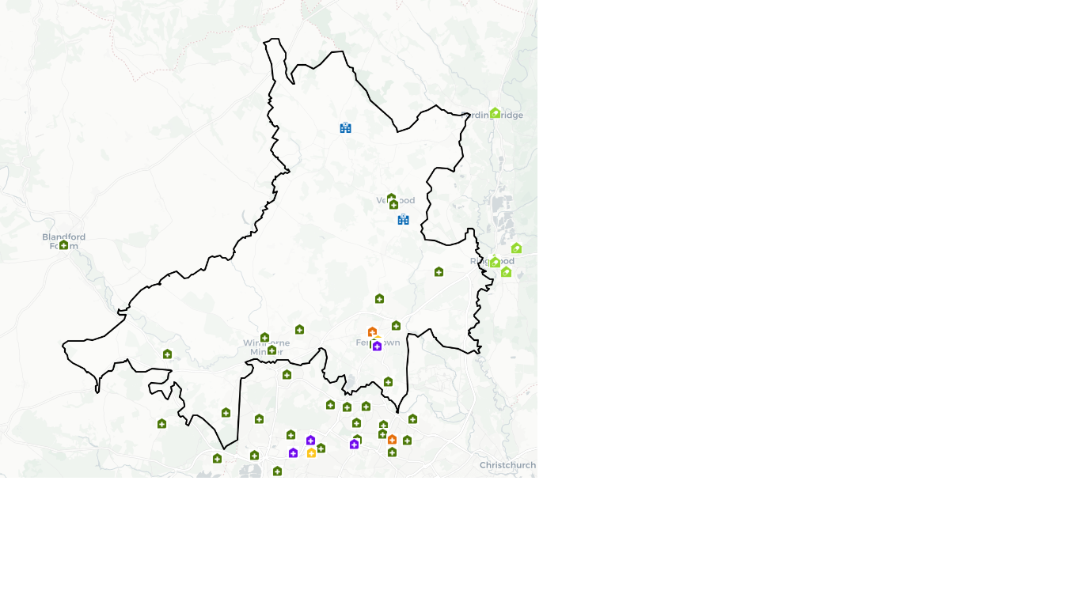

Dorset Mid PNA Locality

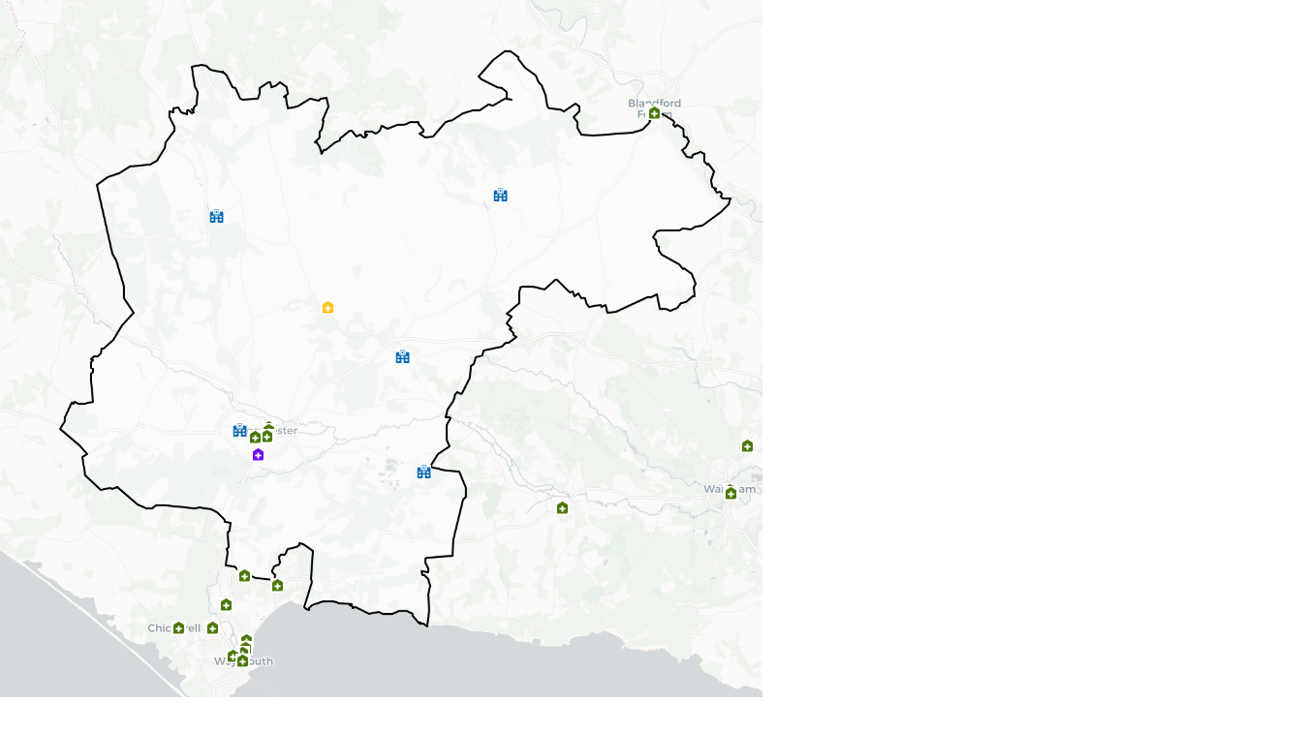

Dorset North PNA Locality

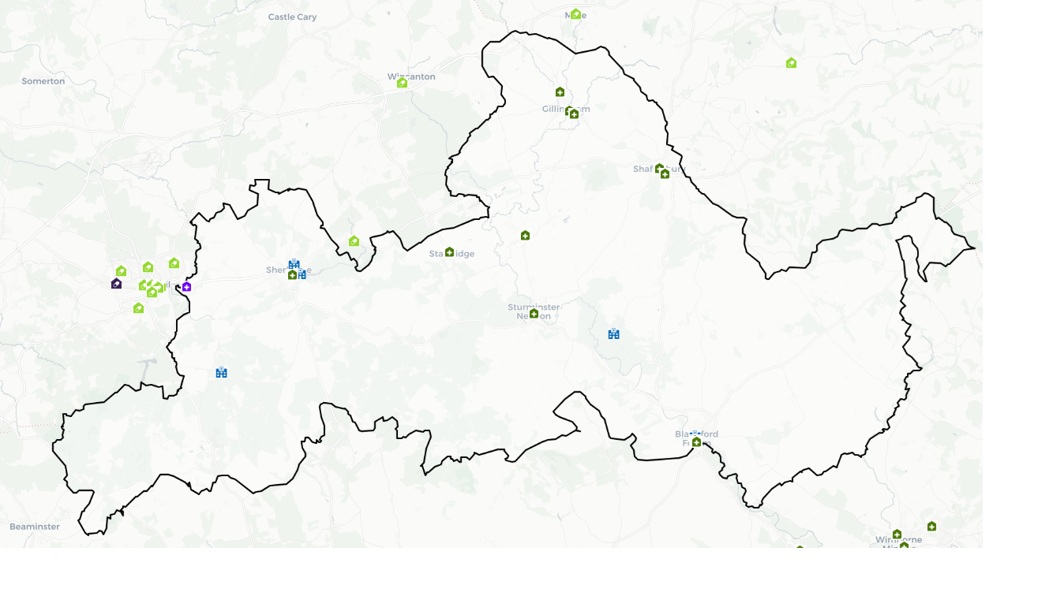

Purbeck PNA Locality

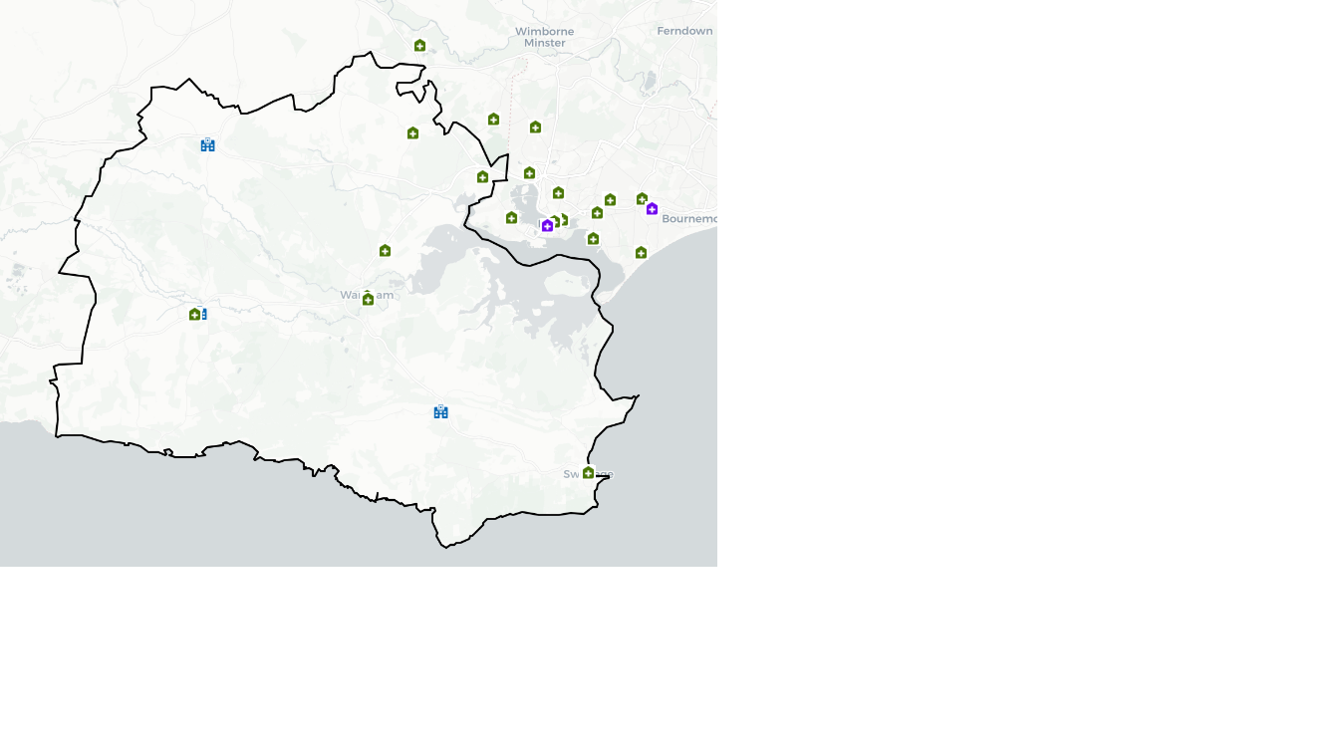

Weymouth & Portland PNA Locality

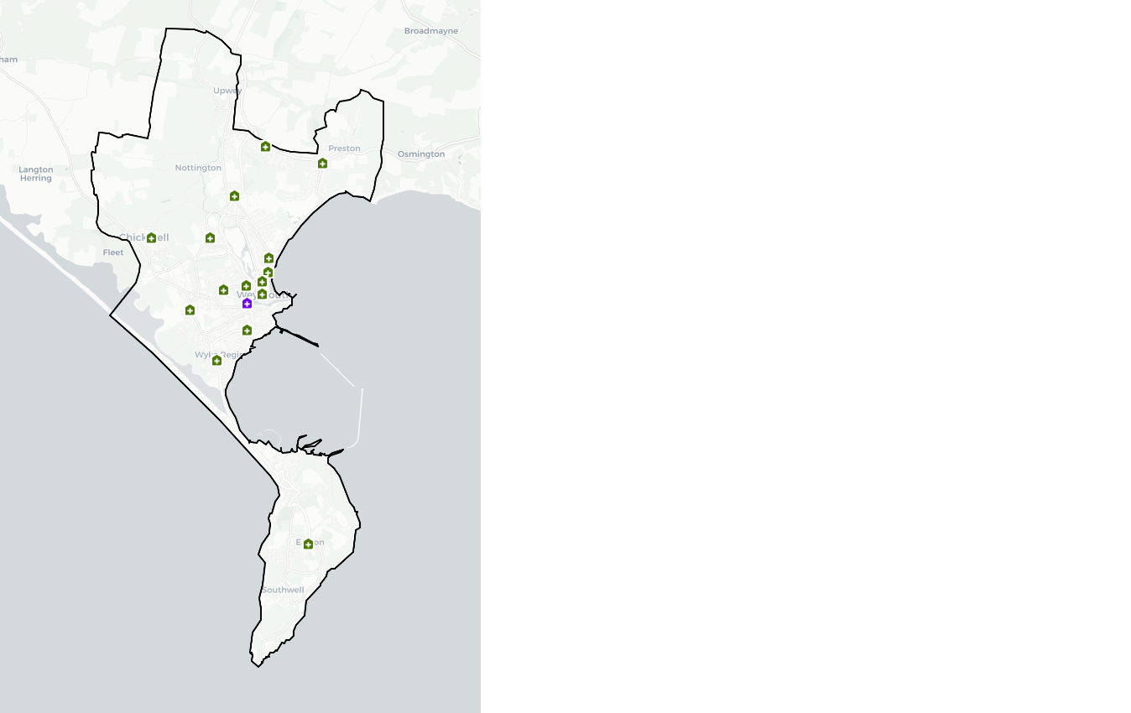

Poole PNA Locality

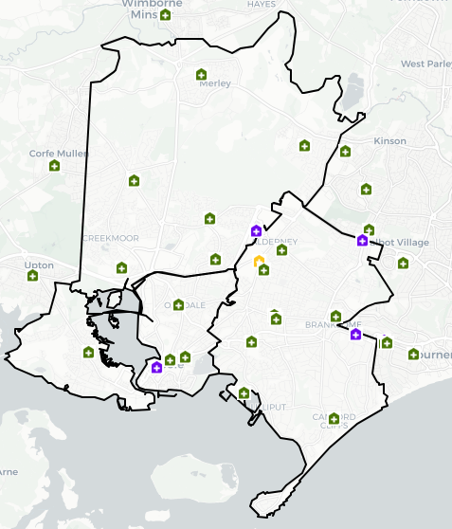

Bournemouth Central & Boscombe PNA Locality

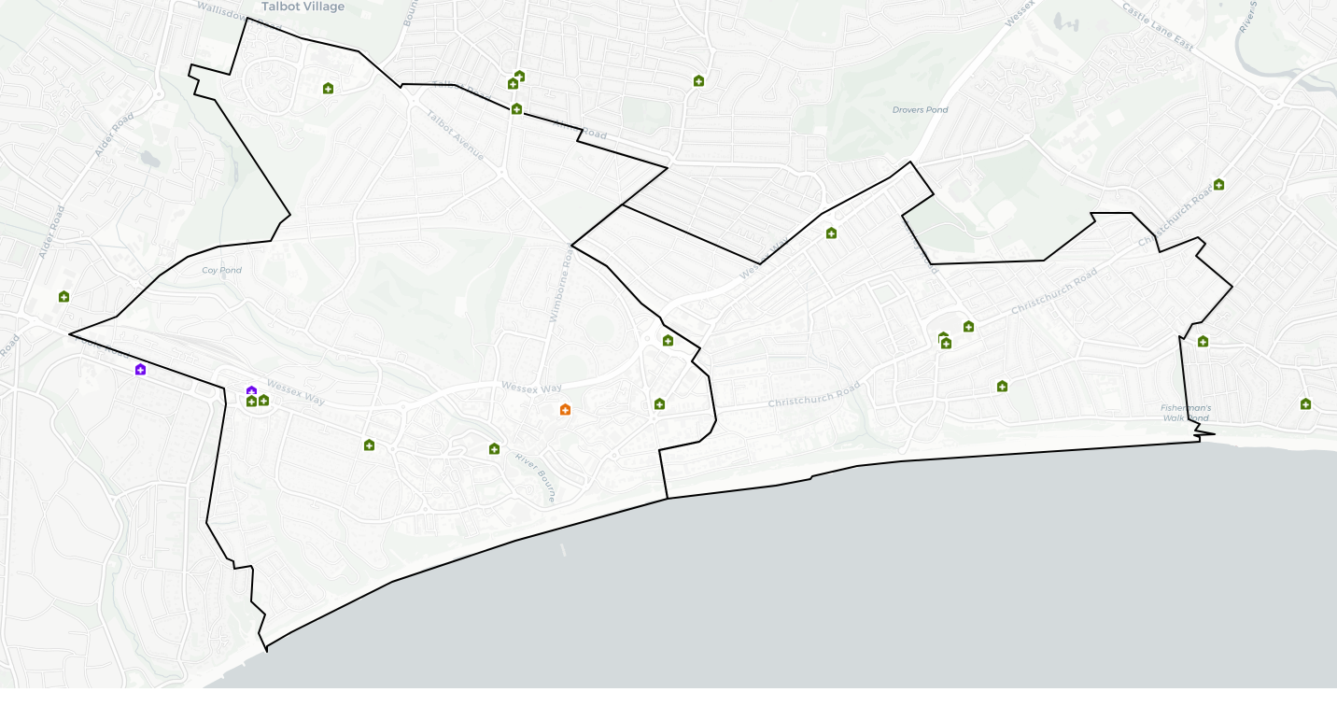

Mid Bournemouth and Kinson & Wallisdown PNA Locality

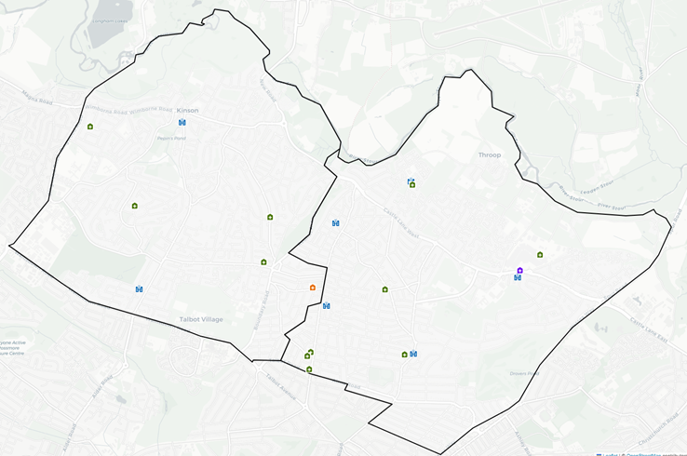

Southbourne and Littledown & Christchurch PCN

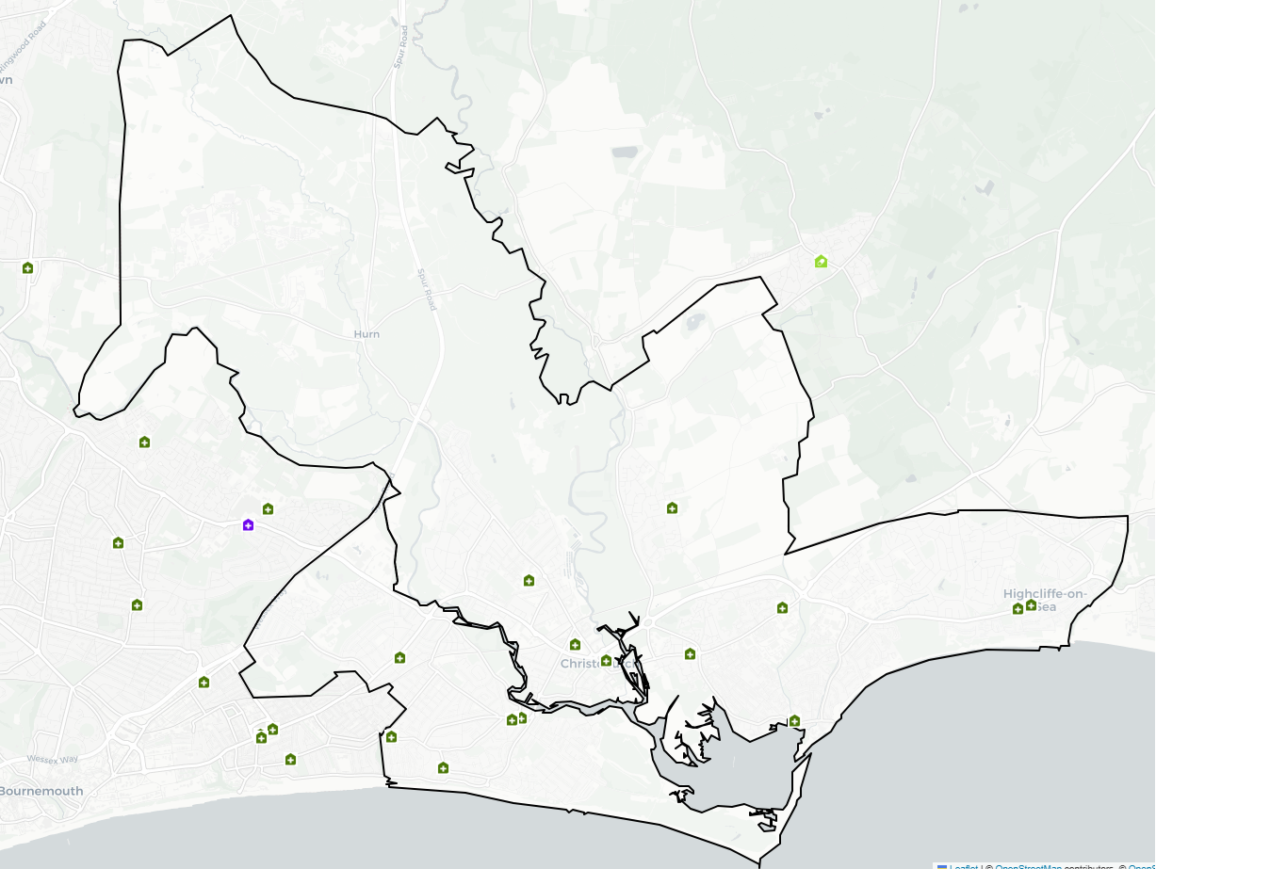

Appendix 5: Consultation report

X

Appendix 6: List of community pharmacies and opening times

ODS CODE | Contractor Name | Postcode | Health and Wellbeing Board | Opening Hours Monday | Opening Hours Tuesday | Opening Hours Wednesday | Opening Hours Thursday | Opening Hours Friday | Opening Hours Saturday | Opening Hours Sunday
FKT39 | Hillview Pharmacy Ltd | BH9 1SE | Bournemouth, Christchurch & Poole (BCP) | 09:00-17:30 | 09:00-17:30 | 09:00-17:30 | 09:00-17:30 | 09:00-17:30 | 09:00-14:30 | Closed
FWH91 | Riverside (Bournemouth) Ltd | BH9 2AB | Bournemouth, Christchurch & Poole (BCP) | 09:00-18:00 | 09:00-18:00 | 09:00-18:00 | 09:00-18:00 | 09:00-18:00 | 09:00-13:00 | Closed
FXP11 | Westcliff Medicines Ltd | BH2 5QR | Bournemouth, Christchurch & Poole (BCP) | 09:00-18:30 | 09:00-18:30 | 09:00-18:30 | 09:00-18:30 | 09:00-18:30 | Closed | Closed
FP298 | Wessex Pharmacies Ltd | BH23 4AS | Bournemouth, Christchurch & Poole (BCP) | 09:00-13:00  14:00-17:30 | 09:00-13:00  14:00-17:30 | 09:00-13:00  14:00-17:30 | 09:00-13:00  14:00-17:30 | 09:00-13:00  14:00-17:30 | 09:00-13:00 | Closed
FVA67 | AA & OO Ltd | BH12 5BU | Bournemouth, Christchurch & Poole (BCP) | 09:00-21:00 | 09:00-21:00 | 09:00-21:00 | 09:00-21:00 | 09:00-21:00 | 09:00-21:00 | 09:00-19:00
FT722 | Pratapsingh Jaysingh Chouhan | BH4 9BB | Bournemouth, Christchurch & Poole (BCP) | 09:00-17:30 | 09:00-17:30 | 09:00-17:30 | 09:00-17:30 | 09:00-17:30 | 09:00-17:30 | Closed
FR043 | Tuckton Pharmacy Ltd | BH6 3JX | Bournemouth, Christchurch & Poole (BCP) | 09:00-17:30 | 09:00-17:30 | 09:00-17:30 | 09:00-17:30 | 09:00-17:30 | 09:00-13:00 | Closed
FR035 | Medicine Clinic Ltd | BH23 2FQ | Bournemouth, Christchurch & Poole (BCP) | 09:00-13:00  14:00-18:00 | 09:00-13:00  14:00-18:00 | 09:00-13:00  14:00-18:00 | 09:00-13:00  14:00-18:00 | 09:00-13:00  14:00-18:00 | 09:00-13:00 | Closed
FHE41 | Tesco Stores Ltd | BH12 1AU | Bournemouth, Christchurch & Poole (BCP) | 09:00-21:00 | 09:00-21:00 | 09:00-21:00 | 09:00-21:00 | 09:00-21:00 | 09:00-21:00 | 10:00-16:00
FCG62 | Tesco Stores Ltd | BH12 4NX | Bournemouth, Christchurch & Poole (BCP) | 09:00-21:00 | 09:00-21:00 | 09:00-21:00 | 09:00-21:00 | 09:00-21:00 | 09:00-21:00 | 10:00-16:00
FVY74 | Superdrug Stores Plc | BH1 4AN | Bournemouth, Christchurch & Poole (BCP) | 09:00-17:30 | 09:00-17:30 | 09:00-17:30 | 09:00-17:30 | 09:00-17:30 | 09:00-17:30 | Closed
FAR75 | Superdrug Stores Plc | BH9 2AQ | Bournemouth, Christchurch & Poole (BCP) | 08:30-17:30 | 08:30-17:30 | 08:30-17:30 | 08:30-17:30 | 08:30-17:30 | 09:00-17:30 | Closed
FGD30 | Pope Kyrellos Ltd | BH23 3QG | Bournemouth, Christchurch & Poole (BCP) | 09:00-13:15  14:15-17:30 | 09:00-13:15  14:15-17:30 | 09:00-13:15  14:15-17:30 | 09:00-13:15  14:15-17:30 | 09:00-13:15  14:15-17:30 | 09:00-13:15 | Closed
FLC78 | Shore Medicines Ltd | BH14 0DJ | Bournemouth, Christchurch & Poole (BCP) | 09:00-18:00 | 09:00-18:00 | 09:00-18:00 | 09:00-18:00 | 09:00-18:00 | Closed | Closed
FQQ97 | L Rowland & Co (Retail) Ltd | BH10 5BG | Bournemouth, Christchurch & Poole (BCP) | 08:30-13:00  13:20-17:30 | 08:30-13:00  13:20-17:30 | 08:30-13:00  13:20-17:30 | 08:30-13:00  13:20-17:30 | 08:30-13:00  13:20-17:30 | 09:00-12:00 | Closed
FGC36 | L Rowland & Co (Retail) Ltd | BH15 2PG | Bournemouth, Christchurch & Poole (BCP) | 09:00-13:00  13:20-17:30 | 09:00-13:00  13:20-17:30 | 09:00-13:00  13:20-17:30 | 09:00-13:00  13:20-17:30 | 09:00-13:00  13:20-17:30 | 09:00-12:00 | Closed
FEH72 | L Rowland & Co (Retail) Ltd | BH15 3DH | Bournemouth, Christchurch & Poole (BCP) | 09:00-13:00  13:20-17:30 | 09:00-13:00  13:20-17:30 | 09:00-13:00  13:20-17:30 | 09:00-13:00  13:20-17:30 | 09:00-13:00  13:20-17:30 | 09:00-12:00 | Closed
FQN44 | L Rowland & Co (Retail) Ltd | BH16 5NJ | Bournemouth, Christchurch & Poole (BCP) | 08:45-13:00  13:20-18:00 | 08:45-13:00  13:20-18:00 | 08:45-13:00  13:20-18:00 | 08:45-13:00  13:20-18:00 | 08:45-13:00  13:20-18:00 | 09:00-12:00 | Closed
FM001 | L Rowland & Co (Retail) Ltd | BH17 7XW | Bournemouth, Christchurch & Poole (BCP) | 09:00-13:00  13:20-18:00 | 09:00-13:00  13:20-18:00 | 09:00-13:00  13:20-18:00 | 09:00-13:00  13:20-18:00 | 09:00-13:00  13:20-18:00 | 09:00-12:00 | Closed
FF719 | L Rowland & Co (Retail) Ltd | BH21 1SQ | Bournemouth, Christchurch & Poole (BCP) | 09:00-13:00  13:20-17:30 | 09:00-13:00  13:20-17:30 | 09:00-13:00  13:20-17:30 | 09:00-13:00  13:20-17:30 | 09:00-13:00  13:20-17:30 | 09:00-12:00 | Closed
FHE81 | L Rowland & Co (Retail) Ltd | BH23 1EU | Bournemouth, Christchurch & Poole (BCP) | 08:45-13:00  13:20-18:00 | 08:45-13:00  13:20-18:00 | 08:45-13:00  13:20-18:00 | 08:45-13:00  13:20-18:00 | 08:45-13:00  13:20-18:00 | 09:00-12:00 | Closed
FAP03 | Charminster Pharmacy Ltd | BH8 9QR | Bournemouth, Christchurch & Poole (BCP) | 09:00-13:00  14:00-17:30 | 09:00-13:00  14:00-17:30 | 09:00-13:00  14:00-17:30 | 09:00-13:00  14:00-17:30 | 09:00-13:00  14:00-17:30 | 09:00-12:00 | Closed
FM738 | L Rowland & Co (Retail) Ltd | BH9 3RE | Bournemouth, Christchurch & Poole (BCP) | 09:00-13:00  13:20:17:30 | 09:00-13:00  13:20:17:30 | 09:00-13:00  13:20:17:30 | 09:00-13:00  13:20:17:30 | 09:00-13:00  13:20:17:30 | 09:00-12:00 | Closed
FKH46 | Medi Innovation Ltd | BH8 8BL | Bournemouth, Christchurch & Poole (BCP) | 09:00-17:30 | 09:00-17:30 | 09:00-17:30 | 09:00-17:30 | 09:00-17:30 | Closed | Closed
FM668 | Poole Bay Pharmacy Ltd | BH4 9HJ | Bournemouth, Christchurch & Poole (BCP) | 08:00-21:00 | 08:00-21:00 | 08:00-21:00 | 08:00-21:00 | 08:00-21:00 | 08:00-21:00 | 10:00-14:00
FRW74 | Click Solutions Ltd | BH14 8UB | Bournemouth, Christchurch & Poole (BCP) | 09:00-17:30 | 09:00-17:30 | 09:00-17:30 | 09:00-17:30 | 09:00-17:30 | 09:00-13:00 | Closed
FW563 | Premoden Ltd | BH12 4HY | Bournemouth, Christchurch & Poole (BCP) | 09:00-13:00  14:00-18:00 | 09:00-13:00  14:00-18:00 | 09:00-13:00  14:00-18:00 | 09:00-13:00  14:00-18:00 | 09:00-13:00  14:00-18:00 | Closed | Closed
FE870 | LP SD Ninety Seven Limited | BH10 5EY | Bournemouth, Christchurch & Poole (BCP) | 08:30-18:30 | 08:30-18:30 | 08:30-18:30 | 08:30-18:30 | 08:30-18:30 | 08:45-12:00 | Closed
FJH06 | LP SD Fifty Limited | BH12 3HF | Bournemouth, Christchurch & Poole (BCP) | 08:30-17:30 | 08:30-17:30 | 08:30-17:30 | 08:30-17:30 | 08:30-17:30 | Closed | Closed
FAA53 | Jaspers Health Ltd | BH10 4DZ | Bournemouth, Christchurch & Poole (BCP) | 09:00-19:00 | 09:00-19:00 | 09:00-19:00 | 09:00-19:00 | 09:00-19:00 | 09:00-18:00 | Closed
FE765 | Waremoss Ltd | BH1 4BH | Bournemouth, Christchurch & Poole (BCP) | 08:30-18:00 | 08:30-18:00 | 08:30-18:00 | 08:30-18:00 | 08:30-18:00 | 09:00-13:00 | Closed
FNC83 | Sutton Chase Ltd | BH23 5ET | Bournemouth, Christchurch & Poole (BCP) | 08:30-18:30 | 08:30-18:30 | 08:30-18:30 | 08:30-18:30 | 08:30-18:30 | Closed | Closed
FKA59 | Sutton Chase Ltd | BH23 5EY | Bournemouth, Christchurch & Poole (BCP) | 08:30-18:00 | 08:30-18:00 | 08:30-18:00 | 08:30-18:00 | 08:30-18:00 | 09:00-17:30 | Closed
FRN27 | Holdenhurst Serivces Ltd | BH8 8EH | Bournemouth, Christchurch & Poole (BCP) | 09:00-18:00 | 09:00-18:00 | 09:00-18:00 | 09:00-18:00 | 09:00-18:00 | 09:00-13:00 | Closed
FHC79 | FRANSIL Ltd | BH6 3LA | Bournemouth, Christchurch & Poole (BCP) | 09:00-13:00  13:30-17:30 | 09:00-13:00  13:30-17:30 | 09:00-13:00  13:30-17:30 | 09:00-13:00  13:30-17:30 | 09:00-13:00  13:30-17:30 | 09:00-13:00 | Closed
FJ896 | Bear Cross Pharma Ltd | BH11 9HS | Bournemouth, Christchurch & Poole (BCP) | 09:00-18:00 | 09:00-18:00 | 09:00-18:00 | 09:00-18:00 | 09:00-18:00 | 09:00-13:00 | Closed
FRN49 | Day Lewis PLC | BH12 5BF | Bournemouth, Christchurch & Poole (BCP) | 08:30-18:30 | 08:30-18:30 | 08:30-18:30 | 08:30-18:30 | 08:30-18:30 | Closed | Closed
FRW86 | Day Lewis PLC | BH13 7LP | Bournemouth, Christchurch & Poole (BCP) | 09:00-17:30 | 09:00-17:30 | 09:00-17:30 | 09:00-17:30 | 09:00-17:30 | 09:00-13:00 | Closed
FME91 | Day Lewis PLC | BH14 8EE | Bournemouth, Christchurch & Poole (BCP) | 08:00-13:00  14:00-18:00 | 08:00-13:00  14:00-18:00 | 08:00-13:00  14:00-18:00 | 08:00-13:00  14:00-18:00 | 08:00-13:00  14:00-18:00 | Closed | Closed
FT397 | Day Lewis PLC | BH5 1LX | Bournemouth, Christchurch & Poole (BCP) | 08:30-18:00 | 08:30-18:00 | 08:30-18:00 | 08:30-18:00 | 08:30-18:00 | 09:00-13:00 | Closed
FA612 | Castle Point (UK) Ltd | BH8 9UD | Bournemouth, Christchurch & Poole (BCP) | 09:00-13:00  14:00-21:00 | 09:00-13:00  14:00-21:00 | 09:00-13:00  14:00-21:00 | 09:00-13:00  14:00-21:00 | 09:00-13:00  14:00-21:00 | 09:00-13:00  14:00-21:00 | 09:00-20:00
FWN53 | Pharmastar Ltd | BH6 3DB | Bournemouth, Christchurch & Poole (BCP) | 08:45-13:00  14:00-17:45 | 08:45-13:00  14:00-17:45 | 08:45-13:00  14:00-17:45 | 08:45-13:00  14:00-17:45 | 08:45-13:00  14:00-17:45 | Closed | Closed
FQ306 | Pharmastar Ltd | BH7 6BW | Bournemouth, Christchurch & Poole (BCP) | 09:00-13:00  14:00-17:30 | 09:00-13:00  14:00-17:30 | 09:00-13:00  14:00-17:30 | 09:00-13:00  14:00-17:30 | 09:00-13:00  14:00-17:30 | 09:00-13:00 | Closed
FCE37 | Shalli Ltd | BH14 0AD | Bournemouth, Christchurch & Poole (BCP) | 09:00-13:00  14:00-17:30 | 09:00-13:00  14:00-17:30 | 09:00-13:00  14:00-17:30 | 09:00-13:00  14:00-17:30 | 09:00-13:00  14:00-17:30 | 09:00-14:00 | Closed
FMA26 | Sibanda Pharma Ltd | BH18 8DP | Bournemouth, Christchurch & Poole (BCP) | 08.30-17:30 | 08.30-17:30 | 08.30-17:30 | 08.30-17:30 | 08.30-17:30 | 09:00-14:00 | Closed
FV796 | Boots UK Ltd | BH1 4BP | Bournemouth, Christchurch & Poole (BCP) | 09:00-13:00  14:00-17:30 | 09:00-13:00  14:00-17:30 | 09:00-13:00  14:00-17:30 | 09:00-13:00  14:00-17:30 | 09:00-13:00  14:00-17:30 | 09:00-13:00  14:00-17:30 | 10:00-16:00
FAX44 | Boots UK Ltd | BH12 1DN | Bournemouth, Christchurch & Poole (BCP) | 09:00-18:00 | 09:00-18:00 | 09:00-18:00 | 09:00-18:00 | 09:00-18:00 | 09:00-18:00 | 10:00-16:00
FC009 | Boots UK Ltd | BH15 1SX | Bournemouth, Christchurch & Poole (BCP) | 09:00-17:30 | 09:00-17:30 | 09:00-17:30 | 09:00-17:30 | 09:00-17:30 | 09:00-17:30 | Closed
FL016 | Lawton Pharmacy Consultants Ltd | BH15 4JQ | Bournemouth, Christchurch & Poole (BCP) | 09:00-18:00 | 09:00-18:00 | 09:00-18:00 | 09:00-18:00 | 09:00-18:00 | 09:00-12:00 | Closed
FA406 | Lawton Pharmacy Consultants Ltd | BH17 8SA | Bournemouth, Christchurch & Poole (BCP) | 09:00-13:00  14:00-18:00 | 09:00-13:00  14:00-18:00 | 09:00-13:00  14:00-18:00 | 09:00-13:00  14:00-18:00 | 09:00-13:00  14:00-18:00 | Closed | Closed
FH405 | Boots UK Ltd | BH18 8DP | Bournemouth, Christchurch & Poole (BCP) | 08:45-12:30  13:30-18:00 | 08:45-12:30  13:30-18:00 | 08:45-12:30  13:30-18:00 | 08:45-12:30  13:30-18:00 | 08:45-12:30  13:30-18:00 | 08:45-12:30  13:30-17:30 | Closed
FQ299 | Boots UK Ltd | BH2 5NL | Bournemouth, Christchurch & Poole (BCP) | 09:00-13:00  14:00-18:00 | 09:00-13:00  14:00-18:00 | 09:00-13:00  14:00-18:00 | 09:00-13:00  14:00-18:00 | 09:00-13:00  14:00-18:00 | 09:00-13:00  14:00-18:00 | 10:30-16:30
FHC47 | Boots UK Ltd | BH23 1QB | Bournemouth, Christchurch & Poole (BCP) | 09:00-17:00 | 09:00-17:00 | 09:00-17:00 | 09:00-17:00 | 09:00-17:00 | 09:00-17:00 | Closed
FV785 | Boots UK Ltd | BH23 1QU | Bournemouth, Christchurch & Poole (BCP) | 09:00-13:00  14:00-18:00 | 09:00-13:00  14:00-18:00 | 09:00-13:00  14:00-18:00 | 09:00-13:00  14:00-18:00 | 09:00-13:00  14:00-18:00 | Closed | Closed
FQ519 | Boots UK Ltd | BH4 9DZ | Bournemouth, Christchurch & Poole (BCP) | 09:00-13:00  14:00-17:30 | 09:00-13:00  14:00-17:30 | 09:00-13:00  14:00-17:30 | 09:00-13:00  14:00-17:30 | 09:00-13:00  14:00-17:30 | 09:00-13:00  14:00-17:30 | Closed
FXM71 | Boots UK Ltd | BH6 3RA | Bournemouth, Christchurch & Poole (BCP) | 09:00-13:00  14:00-17:30 | 09:00-13:00  14:00-17:30 | 09:00-13:00  14:00-17:30 | 09:00-13:00  14:00-17:30 | 09:00-13:00  14:00-17:30 | 09:00-13:00  14:00-17:00 | Closed
FWN86 | Boots UK Ltd | BH8 9UB | Bournemouth, Christchurch & Poole (BCP) | 09:00-20:00 | 09:00-20:00 | 09:00-20:00 | 09:00-20:00 | 09:00-20:00 | 09:00-18:00 | 10:30-16:30
FM254 | Boots UK Ltd | BH9 2HE | Bournemouth, Christchurch & Poole (BCP) | 09:00-14:00  15:00-17:30 | 09:00-14:00  15:00-17:30 | 09:00-14:00  15:00-17:30 | 09:00-14:00  15:00-17:30 | 09:00-14:00  15:00-17:30 | 10:00-14:00  15:00-17:00 | Closed
FP470 | Avicenna Retail Ltd | BH10 4BX | Bournemouth, Christchurch & Poole (BCP) | 08:00-18:30 | 08:00-20:00 | 08:00-18:30 | 08:00-20:00 | 08:00-18:30 | 08:00-12:00 | Closed
FJH73 | Avicenna Retail Ltd | BH11 8DU | Bournemouth, Christchurch & Poole (BCP) | 09:00-17:30 | 09:00-17:30 | 09:00-17:30 | 09:00-17:30 | 09:00-17:30 | 09:00-13:00 | Closed
FLG28 | Avicenna Retail Ltd | BH11 9TW | Bournemouth, Christchurch & Poole (BCP) | 09:00-17:30 | 09:00-17:30 | 09:00-17:30 | 09:00-17:30 | 09:00-17:30 | 09:00-12:00 | Closed
FM329 | Asda Stores Ltd | BH15 1JQ | Bournemouth, Christchurch & Poole (BCP) | 09:00-12:30  13:00-16:30  17:00-21:00 | 09:00-12:30  13:00-16:30  17:00-21:00 | 09:00-12:30  13:00-16:30  17:00-21:00 | 09:00-12:30  13:00-16:30  17:00-21:00 | 09:00-12:30  13:00-16:30  17:00-21:00 | 09:00-12:30  13:00-16:30  17:00-21:00 | 10:00-16:00
FHC36 | Asda Stores Ltd | BH8 8DL | Bournemouth, Christchurch & Poole (BCP) | 09:00-20:00 | 09:00-20:00 | 09:00-20:00 | 09:00-20:00 | 09:00-20:00 | 09:00-20:00 | 11:00-17:00
FE379 | Arrowedge Ltd | BH17 9DW | Bournemouth, Christchurch & Poole (BCP) | 09:00-13:00  14:00-17:30 | 09:00-13:00  14:00-17:30 | 09:00-13:00  14:00-17:30 | 09:00-13:00  14:00-17:30 | 09:00-13:00  14:00-17:30 | 09:00-11:30 | Closed
FJG24 | Arrowedge Ltd | BH18 8DP | Bournemouth, Christchurch & Poole (BCP) | 09:00-13:00  14:00-17:30 | 09:00-13:00  14:00-17:30 | 09:00-13:00  14:00-17:30 | 09:00-13:00  14:00-17:30 | 09:00-13:00  14:00-17:30 | 09:00-13:00 | Closed
FE691 | Arrowedge Ltd | BH4 9DZ | Bournemouth, Christchurch & Poole (BCP) | 09:00-13:00  14:00-18:00 | 09:00-13:00  14:00-18:00 | 09:00-13:00  14:00-18:00 | 09:00-13:00  14:00-18:00 | 09:00-13:00  14:00-18:00 | 09:00-13:00 | Closed
FPN51 | Weymouth Pharma Ltd | DT4 0AE | Dorset | 09:00-13:00  14:00-18:00 | 09:00-13:00  14:00-18:00 | 09:00-13:00  14:00-18:00 | 09:00-13:00  14:00-18:00 | 09:00-13:00  14:00-18:00 | 09:00-13:00 | Closed
FXF11 | Wessex Pharmacies Ltd | DT4 7JJ | Dorset | 09:00-13:00  14:15-17:30 | 09:00-13:00  14:15-17:30 | 09:00-13:00  14:15-17:30 | 09:00-13:00  14:15-17:30 | 09:00-13:00  14:15-17:30 | 09:00-13:00 | Closed
FCM76 | Wessex Pharmacies Ltd | DT4 9DJ | Dorset | 09:00-13:00  14:15-17:30 | 09:00-13:00  14:15-17:30 | 09:00-13:00  14:15-17:30 | 09:00-13:00  14:15-17:30 | 09:00-13:00  14:15-17:30 | 09:00-13:00 | Closed
FRL80 | Wellbeing (United Kingdom) Ltd | BH21 4AY | Dorset | 09:00-18:00 | 09:00-18:00 | 09:00-13:00 | 09:00-18:00 | 09:00-18:00 | Closed | Closed
FE320 | Bestway National Chemists Ltd | BH19 1AE | Dorset | 08:30-18:30 | 08:30-18:30 | 08:30-18:30 | 08:30-18:30 | 08:30-18:30 | Closed | Closed
FQ123 | Bestway National Chemists Ltd | BH19 1AF | Dorset | 09:00-12:30  13:30-18:00 | 09:00-12:30  13:30-18:00 | 09:00-12:30  13:30-18:00 | 09:00-12:30  13:30-18:00 | 09:00-12:30  13:30-18:00 | Closed | Closed
FGD60 | Bestway National Chemists Ltd | DT4 0LX | Dorset | 09:00-18:00 | 09:00-18:00 | 09:00-18:00 | 09:00-18:00 | 09:00-18:00 | Closed | Closed
FJV68 | Bestway National Chemists Ltd | DT4 7BX | Dorset | 09:00-18:00 | 09:00-18:00 | 09:00-18:00 | 09:00-18:00 | 09:00-18:00 | Closed | Closed
FGD26 | Bestway National Chemists Ltd | DT4 9PQ | Dorset | 09:00-18:00 | 09:00-18:00 | 09:00-18:00 | 09:00-18:00 | 09:00-18:00 | Closed | Closed
FN020 | Layade Pharma Ltd | DT4 9SS | Dorset | 09:00-13:00  14:00-17:45 | 09:00-13:00  14:00-17:45 | 09:00-13:00  14:00-17:45 | 09:00-13:00  14:00-17:45 | 09:00-13:00  14:00-17:45 | 09:00-12:00 | Closed
FK141 | Bestway National Chemists Ltd | DT6 3LF | Dorset | 09:00-17:30 | 09:00-17:30 | 09:00-17:30 | 09:00-17:30 | 09:00-17:30 | 09:00-13:00 | Closed
FPA91 | Bestway National Chemists Ltd | DT9 3BA | Dorset | 09:00-14:00  14:30-17:30 | 09:00-14:00  14:30-17:30 | 09:00-14:00  14:30-17:30 | 09:00-14:00  14:30-17:30 | 09:00-14:00  14:30-17:30 | 09:00-13:00 | Closed
FCP93 | Aunpharma Ltd | DT1 2LW | Dorset | 09:00-17:30 | 09:00-17:30 | 09:00-17:30 | 09:00-17:30 | 09:00-17:30 | 09:00-13:00 | Closed
FXG05 | Pharmland Ltd | BH31 6DW | Dorset | 08:00-20:00 | 08:00-20:00 | 08:00-20:00 | 08:00-20:00 | 08:00-20:00 | 09:00-16:00 | Closed
FTT38 | Tout Ltd | DT1 1QR | Dorset | 08:30-18:30 | 08:30-18:30 | 08:30-18:30 | 08:30-18:30 | 08:30-18:30 | 08:30-15:30 | Closed
FVR30 | Everyou Healthcare Ltd | BH21 1NL | Dorset | 09:00-13:00  14:00-18:00 | 09:00-13:00  14:00-18:00 | 09:00-13:00  14:00-18:00 | 09:00-13:00  14:00-18:00 | 09:00-13:00  14:00-18:00 | Closed | Closed
FWL38 | Avicenna Retail Ltd | SP8 4XS | Dorset | 09:00-13:30  14:30-18:30 | 09:00-13:30  14:30-18:30 | 09:00-13:30  14:30-18:30 | 09:00-13:30  14:30-18:30 | 09:00-13:30  14:30-18:30 | Closed | Closed
FL223 | Flagship (Dorset) Ltd | DT9 3BA | Dorset | 09:00-17:30 | 09:00-17:30 | 09:00-17:30 | 09:00-17:30 | 09:00-17:30 | 09:00-14:00 | Closed
FM887 | Tesco Stores Ltd | BH22 9TH | Dorset | 08:00-19:00 | 08:00-19:00 | 08:00-19:00 | 08:00-19:00 | 08:00-19:00 | 08:00-18:00 | 10:00-16:00
FMG47 | Tesco Stores Ltd | DT1 2RY | Dorset | 09:00-21:00 | 09:00-21:00 | 09:00-21:00 | 09:00-21:00 | 09:00-21:00 | 09:00-21:00 | 10:00-16:00
FN247 | Superdrug Stores Plc | DT1 1BS | Dorset | 08:30-14:00  14:30-17:30 | 08:30-17:30 | 08:30-17:30 | 08:30-17:30 | 08:30-17:30 | 09:00-17:30 | Closed
FAW80 | MB Stalbridge Ltd | DT10 2LL | Dorset | 09:00-13:00  14:00-17:30 | 09:00-13:00  14:00-17:30 | 09:00-13:00  14:00-17:30 | 09:00-13:00  14:00-17:30 | 09:00-13:00  14:00-17:30 | 09:00-13:00 | Closed
FGJ07 | Everyou Healthcare Ltd | BH20 7AX | Dorset | 09:00-13:00  14:00-18:00 | 09:00-13:00  14:00-18:00 | 09:00-13:00  14:00-18:00 | 09:00-13:00  14:00-18:00 | 09:00-13:00  14:00-18:00 | Closed | Closed
FHA62 | Ferndown Healthcare Ltd | BH22 9HB | Dorset | 08:45-13:00  13:20-18:00 | 08:45-13:00  13:20-18:00 | 08:45-13:00  13:20-18:00 | 08:45-13:00  13:20-18:00 | 08:45-13:00  13:20-18:00 | 09:00-12:00 | Closed
FWV19 | L Rowland & Co (Retail) Ltd | DT3 6LD | Dorset | 09:00-13:00  14:00-18:00 | 09:00-13:00  14:00-18:00 | 09:00-13:00  14:00-18:00 | 09:00-13:00  14:00-18:00 | 09:00-13:00  14:00-18:00 | Closed | Closed
FAL73 | L Rowland & Co (Retail) Ltd | DT3 6NQ | Dorset | 09:00-13:00  13:20-18:00 | 09:00-13:00  13:20-18:00 | 09:00-13:00  13:20-18:00 | 09:00-13:00  13:20-18:00 | 09:00-13:00  13:20-18:00 | 09:00-12:00 | Closed
FN115 | Aunpharma Ltd | DT1 2FD | Dorset | 09:00-17:30 | 09:00-17:30 | 09:00-17:30 | 09:00-17:30 | 09:00-17:30 | 09:00-12:00 | Closed
FHC80 | Avicenna Retail Ltd | SP8 4FA | Dorset | 09:00-13:00  14:00-18:15 | 09:00-13:00  14:00-18:15 | 09:00-13:00  14:00-18:15 | 09:00-13:00  14:00-18:15 | 09:00-13:00  14:00-18:15 | Closed | Closed
FPE70 | Medicine Clinic Ltd | BH22 8EB | Dorset | 09:00-18:30 | 09:00-18:30 | 09:00-18:30 | 09:00-18:30 | 09:00-18:30 | 09:00-13:00 | Closed
FPT55 | Wm Morrisons Supermarkets Plc | BH31 6UQ | Dorset | 09:00-13:00  14:00-19:00 | 09:00-13:00  14:00-19:00 | 09:00-13:00  14:00-19:00 | 09:00-13:00  14:00-19:00 | 09:00-13:00  14:00-19:00 | 09:00-13:00  14:00-18:00 | 10:00-16:00
FMK10 | Wm Morrisons Supermarkets Plc | DT3 5AX | Dorset | 09:00-13:00  14:00-19:00 | 09:00-13:00  14:00-19:00 | 09:00-13:00  14:00-19:00 | 09:00-13:00  14:00-19:00 | 09:00-13:00  14:00-19:00 | 09:00-13:00  14:00-18:00 | 10:00-16:00
FL781 | Apharm Ltd | BH22 0HX | Dorset | 09:00-13:00  14:00-18:00 | 09:00-13:00  14:00-18:00 | 09:00-13:00  14:00-18:00 | 09:00-13:00  14:00-18:00 | 09:00-13:00  14:00-18:00 | 09:00-13:00 | Closed
FRP28 | Rosepharm Ltd | DT10 1PU | Dorset | 09:00-13:00  14:00-17:30 | 09:00-13:00  14:00-17:30 | 09:00-13:00  14:00-17:30 | 09:00-13:00  14:00-17:30 | 09:00-13:00  14:00-17:30 | 09:00-12:30 | Closed
FN499 | Everyou Healthcare Ltd | BH16 6BG | Dorset | 09:00-13:00  14:00-18:00 | 09:00-13:00  14:00-18:00 | 09:00-13:00  14:00-18:00 | 09:00-13:00  14:00-18:00 | 09:00-13:00  14:00-18:00 | Closed | Closed
FM216 | LP SD Fifty Limited | DT4 7AW | Dorset | 08:30-17:30 | 08:30-17:30 | 08:30-17:30 | 08:30-17:30 | 08:30-17:30 | 09:00-12:00 | Closed
FCV51 | LP SD Fifty Limited | DT6 5BN | Dorset | 08:45-18:00 | 08:45-18:00 | 08:45-18:00 | 08:45-18:00 | 08:45-18:00 | 09:30-12:00 | Closed
FM042 | LP SD Eight Limited | DT7 3LS | Dorset | 09:00-18:00 | 09:00-18:00 | 09:00-18:00 | 09:00-18:00 | 09:00-18:00 | 09:00-12:30 | Closed
FG146 | LP SD Nine limited | SP7 8DH | Dorset | 08:30-18:30 | 08:30-18:30 | 08:30-18:30 | 08:30-18:30 | 08:30-18:30 | 09:00-12:00 | Closed
FTE44 | Avicenna Retail Ltd | SP8 4AG | Dorset | 09:00-12:30  13:30-17:30 | 09:00-12:30  13:30-17:30 | 09:00-12:30  13:30-17:30 | 09:00-12:30  13:30-17:30 | 09:00-12:30  13:30-17:30 | 09:00-11:30 | Closed
FFE58 | Ferndown Pharmacy Ltd | BH22 9AG | Dorset | 09:00-21:00 | 09:00-21:00 | 09:00-21:00 | 09:00-21:00 | 09:00-21:00 | 09:00-13:00  17:00-21:00 | 10:00-14:00
FWV11 | Day Lewis PLC | BH20 4LR | Dorset | 09:00-17:30 | 09:00-17:30 | 09:00-17:30 | 09:00-17:30 | 09:00-17:30 | Closed | Closed
FQD14 | Day Lewis PLC | BH23 7JN | Dorset | 09:00-18:00 | 09:00-18:00 | 09:00-18:00 | 09:00-18:00 | 09:00-18:00 | Closed | Closed
FX758 | Day Lewis PLC | DT3 4DT | Dorset | 08:30-13:00  14:00-17:30 | 08:30-13:00  14:00-17:30 | 08:30-13:00  14:00-17:30 | 08:30-13:00  14:00-17:30 | 08:30-13:00  14:00-17:30 | Closed | Closed
FLX51 | Medicine Clinic Ltd | BH21 2SE | Dorset | 09:00-13:00  14:00-18:00 | 09:00-13:00  14:00-18:00 | 09:00-13:00  14:00-18:00 | 09:00-13:00  14:00-18:00 | 09:00-13:00  14:00-18:00 | 09:00-13:00 | Closed
FYM76 | FG Lock Ltd | DT6 6PX | Dorset | 09:00-13:00  14:00-17:30 | 09:00-13:00  14:00-17:30 | 09:00-13:00  14:00-17:30 | 09:00-13:00  14:00-17:30 | 09:00-13:00  14:00-17:30 | 09:00-13:00 | Closed
FV817 | Boots UK Ltd | BA21 5BT | Dorset | 09:00-13:00  14:00-21:00 | 09:00-13:00  14:00-21:00 | 09:00-13:00  14:00-21:00 | 09:00-13:00  14:00-21:00 | 09:00-13:00  14:00-21:00 | 09:00-13:00  14:00-21:00 | 10:00-16:00
FFA03 | Boots UK Ltd | BH19 1AB | Dorset | 09:00-13:00  14:00-17:30 | 09:00-13:00  14:00-17:30 | 09:00-13:00  14:00-17:30 | 09:00-13:00  14:00-17:30 | 09:00-13:00  14:00-17:30 | 09:00-13:00  14:00-17:30 | 10:00-16:00
FD255 | Dharita and Piyush Ltd | BH20 4AF | Dorset | 09:00-18:30 | 09:00-18:30 | 09:00-18:30 | 09:00-18:30 | 09:00-18:30 | 09:00-18:30 | Closed
FQA35 | Boots UK Ltd | BH20 6EJ | Dorset | 09:00-18:00 | 09:00-18:00 | 09:00-18:00 | 09:00-18:00 | 09:00-18:00 | 09:00-16:30 | Closed
FME62 | QJP Ltd | BH21 1AP | Dorset | 09:00-19:00 | 09:00-19:00 | 09:00-19:00 | 09:00-19:00 | 09:00-19:00 | 08:30-17:00 | Closed
FAM12 | Boots UK Ltd | BH21 3LN | Dorset | 09:00-18:00 | 09:00-18:00 | 09:00-18:00 | 09:00-18:00 | 09:00-18:00 | 09:00-13:00 | Closed
FMA93 | Boots UK Ltd | BH22 9AL | Dorset | 09:00-13:00  14:00-19:00 | 09:00-13:00  14:00-19:00 | 09:00-13:00  14:00-19:00 | 09:00-13:00  14:00-19:00 | 09:00-13:00  14:00-19:00 | 08:30-13:00  14:00-17:30 | 10:00-16:00
FDA03 | Boots UK Ltd | DT1 1BQ | Dorset | 09:00-17:00 | 09:00-17:00 | 09:00-17:00 | 09:00-17:00 | 09:00-17:00 | 09:00-17:00 | Closed
FCJ53 | Boots UK Ltd | DT10 1AS | Dorset | 09:00-18:00 | 09:00-18:00 | 09:00-18:00 | 09:00-18:00 | 09:00-18:00 | 09:00-16:00 | Closed
FKN07 | Boots UK Ltd | DT11 7AR | Dorset | 09:00-18:00 | 09:00-18:00 | 09:00-18:00 | 09:00-18:00 | 09:00-18:00 | 09:00-17:30 | Closed
FXK56 | Weymouth pharma Ltd | DT11 7DX | Dorset | 09:00-13:15  14:15-17:30 | 09:00-13:15  14:15-17:30 | 09:00-13:15  14:15-17:30 | 09:00-13:15  14:15-17:30 | 09:00-13:15  14:15-17:30 | 09:00-16:00 | Closed
FF509 | Boots UK Ltd | DT4 8LY | Dorset | 08:30-13:30  14:30-17:30 | 08:30-13:30  14:30-17:30 | 08:30-13:30  14:30-17:30 | 08:30-13:30  14:30-17:30 | 08:30-13:30  14:30-17:30 | 08:30-13:30  14:30-17:30 | 10:00-16:00
FVN62 | Boots UK Ltd | DT4 9BG | Dorset | 09:00-18:00 | 09:00-18:00 | 09:00-18:00 | 09:00-18:00 | 09:00-18:00 | Closed | Closed
FQF92 | Boots UK Ltd | DT5 1BX | Dorset | 09:00-18:00 | 09:00-18:00 | 09:00-18:00 | 09:00-18:00 | 09:00-18:00 | 09:00-17:00 | Closed
FXH34 | Boots UK Ltd | DT6 3QJ | Dorset | 09:00-17:30 | 09:00-17:30 | 09:00-17:30 | 09:00-17:30 | 09:00-17:30 | 09:00-17:00 | Closed
FHG74 | SNJ Health Ltd | DT7 3QF | Dorset | 09:00-13:00  14:00-17:30 | 09:00-13:00  14:00-17:30 | 09:00-13:00  14:00-17:30 | 09:00-13:00  14:00-17:30 | 09:00-13:00  14:00-17:30 | 09:00-13:00  14:00-17:00 | Closed
FQK43 | Boots UK Ltd | DT9 3BA | Dorset | 09:00-13:00  14:00-17:30 | 09:00-13:00  14:00-17:30 | 09:00-13:00  14:00-17:30 | 09:00-13:00  14:00-17:30 | 09:00-13:00  14:00-17:30 | 09:00-13:00  14:00-17:30 | Closed
FPC33 | Boots UK Ltd | SP7 8JE | Dorset | 09:00-13:30  14:30-17:30 | 09:00-13:30  14:30-17:30 | 09:00-13:30  14:30-17:30 | 09:00-13:30  14:30-17:30 | 09:00-13:30  14:30-17:30 | 09:00-13:30  14:30-17:30 | Closed
FFW83 | Flagship (Dorset) Ltd | DT8 3AA | Dorset | 09:00-13:00  14:00-17:30 | 09:00-13:00  14:00-17:30 | 09:00-13:00  14:00-17:30 | 09:00-13:00  14:00-17:30 | 09:00-13:00  14:00-17:30 | 09:00-11:30 | Closed
FWH67 | Super Happy Wing Ltd | BH24 2HP | Dorset | 09:00-17:30 | 09:00-17:30 | 09:00-17:30 | 09:00-17:30 | 09:00-17:30 | 09:00-13:00 | Closed
FHC86 | Asda Stores Ltd | DT4 8JQ | Dorset | 09:00-12:30  13:00-16:30  17:00-21:00 | 09:00-12:30  13:00-16:30  17:00-21:00 | 09:00-12:30  13:00-16:30  17:00-21:00 | 09:00-12:30  13:00-16:30  17:00-21:00 | 09:00-12:30  13:00-16:30  17:00-21:00 | 09:00-12:30  13:00-16:30  17:00-21:00 | 10:00-16:00

Appendix 7: List of distance selling pharmacies and opening times

ODS CODE | Contractor Name | Postcode | Health and Wellbeing Board | Opening Hours Monday | Opening Hours Tuesday | Opening Hours Wednesday | Opening Hours Thursday | Opening Hours Friday | Opening Hours Saturday | Opening Hours Sunday
FAE92 | Automeds Pharmacy Ltd | BH12 3PG | Bournemouth, Christchurch & Poole (BCP) | 09:00-13:00  14:00-18:00 | 09:00-13:00  14:00-18:00 | 09:00-13:00  14:00-18:00 | 09:00-13:00  14:00-18:00 | 09:00-13:00  14:00-18:00 | Closed | Closed
FXL79 | P & D Cards Ltd | BH22 9HU | Dorset | 09:00-12:30  13:00-17:30 | 09:00-12:30  13:00-17:30 | 09:00-12:30  13:00-17:30 | 09:00-12:30  13:00-17:30 | 09:00-12:30  13:00-17:30 | Closed | Closed
FRD44 | Automeds Pharmacy Ltd | DT2 7UA | Dorset | 09:00 - 13:30  14:00 - 17:30 | 09:00 - 13:30  14:00 - 17:30 | 09:00 - 13:30  14:00 - 17:30 | 09:00 - 13:30  14:00 - 17:30 | 09:00 - 13:30  14:00 - 17:30 | Closed | Closed

Appendix 8: List of dispensing appliance contractors and opening times

ODS CODE | Contractor Name | Postcode | Health and Wellbeing Board | Opening Hours Monday | Opening Hours Tuesday | Opening Hours Wednesday | Opening Hours Thursday | Opening Hours Friday | Opening Hours Saturday | Opening Hours Sunday
FWP06 | Salts Healthcare Ltd | BH1 1HF | Bournemouth, Christchurch & Poole (BCP) | 09:00-17:00 | 09:00-17:00 | 09:00-17:00 | 09:00-17:00 | 09:00-17:00 | 09:00-17:00 | Closed
FCY62 | Fittleworth Medical Ltd | BH9 2RE | Bournemouth, Christchurch & Poole (BCP) | 09:00-1500 | 09:00-1500 | 09:00-1500 | 09:00-1500 | 09:00-1500 | Closed | Closed
FMK11 | Respond Healthcare Ltd | BH22 9NG | Dorset | 09:00-17:00 | 09:00-17:00 | 09:00-17:00 | 09:00-17:00 | 09:00-17:00 | Closed | Closed

