
Dorset Council
PUBLIC HEALTH ACT 1961
DORSET COUNCIL PURBECK WATERCRAFT BYELAW 2027
Dorset Council in exercise of powers conferred by section 76 of the Public Health Act 1961 makes the following byelaw.
Citation
This byelaw may be cited as the Dorset Council Purbeck Watercraft Byelaw 2027.
Commencement
This byelaw comes into force on the date on which it is confirmed by the Secretary of State.
Interpretation
- In this byelaw:

- 'buoys’ mean floating devices anchored in water, used to mark locations, guide navigation, or act as speed markers;

- 'moorings’ mean fixed structures or anchors used to secure a vessel in place, preventing it from drifting due to wind, currents, or tides;

- ‘navigator’ means a person who has charge or control of a watercraft or, being present, is entitled to give orders to the person having charge or control of it;

- ‘specified area’ means the areas detailed in Schedule 1;

- ‘the council’ means Dorset Council;

- ‘voluntary No Anchor Zone’ (VNAS) means the area set out in the Studland Bay MCZ Habitat Protection Strategy 2022-26, with coordinates shown in Part 1 (d) and area drawn on Map 4;

- ‘Personal Watercraft’ means a watercraft intended for sports and leisure purposes of less than 4 meters in hull length which uses a propulsion engine having a water jet pump as its primary source of propulsion and designed to be operated by a person or persons sitting, standing or kneeling on, rather than within the confines of, a hull;

- ‘Jet Bike’ means any watercraft (not being a structure which by reason of its concave shape provides buoyancy for the carriage of persons or goods) propelled by a water jet engine or other mechanical means of propulsion and steered either:
    - by means of a handlebar-operated linkage system (with or without a rudder at the stern);
    - by the person or persons riding the craft using their bodyweight for the purpose; or
    - by a combination of the methods referred to in (a) and (b) above;

- ‘Wing Foils’ refers to the use of an inflatable handheld Wing used by the rider of non-powered hydrofoil (Foil) board;

- ‘E-Foils’ mean battery powered hydrofoil boards with a small jet for propulsion. They are a type of Personal Watercraft;

- ‘ watercraft’ means any vessel that is designed to travel on or through water, whether powered by an engine, sail, or manually operated. This definition includes both motorised, electric and non-motorised vessels, as well as remote-controlled or autonomous watercraft. Examples include (but are not limited to);
- Personal Watercraft (PWC) e.g. jet skis, jet bikes, E-Foils;
- motorboats;
- speedboats;
- kayaks;
- canoes;
- paddleboards;
- kitesurfs;
- windsurfs;
- Gig rowers;
- wing foils and;
- sailboats.

Operation of watercraft
- A navigator must not cause or permit any watercraft to exceed a speed faster than 5 knots through water in the specified areas during the period from 15 March and 30 October (inclusive).

- Paragraph 2 does not apply to a navigator who is:
  - taking part in an event organised by the council or by any person with consent to the council in writing;
  - providing safety facilities at such an event and using any watercraft designated for that purpose by the person organising the event; or
  - acting in a rescue operation or emergency.
Avoidance of danger
- Within the byelaw specified areas a navigator must use care and caution to:
  - not endanger lives or cause injury;
  - not be a nuisance to persons or wildlife; and
  - not cause damage to other watercraft, moorings or buoys.
Use of internal combustion engines
- A navigator must not use a powered watercraft fitted with an internal combustion engine in a specified area unless the engine is fitted with a silencer that suitably reduces the noise caused by the escaping of exhaust gasses from the engine.
Offences
- Anyone who contravenes or fails to comply with any provision contained in the byelaw is committing an offence and is liable on summary conviction to a fine not exceeding level 3 on the standard scale.

Saving of Crown and other rights
- None of the byelaws grant or affect the Crown's rights or interests in the foreshore and seabed below high watermark, nor do they impact public rights or legal privileges over these areas.
Revocation
- “The seaside pleasure boats byelaw 2013” made by Purbeck District Council on 11th day of October 2013 is revoked.

I certify that the above byelaw was made by Dorset Council at their meeting(?) on DD MMMMMMM YYYY.

[Insert Signature]

[Name of signatory]
[Job Title]
Dorset Council
[Address]

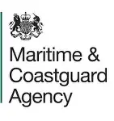

The Secretary of State for Transport in exercise of the power conferred by section 76(2) of the Public Health Act 1961, confirms the Dorset Council Purbeck Watercraft Byelaw 2025 made by Dorset Council on DD MMMMMMM YYYYY.

…………………………………………………………….
A Senior Civil Servant for, and on behalf of, the Secretary of State for XXXX

Date:

Schedule 1
Part 1
This byelaw applies to the following specified areas:
- Lulworth Cove – landward of a straight line drawn between West point (50°37'1"N, 2°14'53"W) and East Point (50°37'0"N, 2°14'46"W), as shown by the broken line on map 1 in Part 2 Schedule 1;
- Kimmeridge bay – landward of a straight line extending from a point on Kimmeridge Ledges 150 metres west of Clavel Tower (50°36'36"N, 2°8'19"W) to the most eastern end of the Channel Flats (50°36'27"N, 2°7'55"W) shown by the broken line on map 2 in Part 2 schedule 1;
- Swanage bay enclosed within and on the landward side of the defined speed marker buoy line that are placed 200m out from mean high water mark on map 3 in Part 2 Schedule 1;
Buoy/position | Latitude | Longitude | Comments
A3 | 53°25′59.86″N | 6°48′45.22″W | Fixed Point
B3 |  |  | Laid in a straight line following the bay from buoy A3 to buoy J3 approximately equally spaced
C3
D3
E3
F3
G3
H3
I3
J3 | 53°25′46.15″N | 6°49′27.76″W | Fixed Point
K3 |  |  | Laid in a straight line following the bay from buoy J3 to buoy R3 approximately equally spaced
L3
M3
N3
O3
P
Q
R3 | 53°25′44.79″N | 6°50′7.80″W | Fixed point
E
V3 | 53°25′53.90″N | 6°50′1.08″W | Fixed point
W3 | 53°25′58.44″N | 6°50′2.57″W
X3
Y3 | 53°26′0.99″N | 6°50′13.17″W | Fixed point
Z3
AA3 | 53°26′7.26″N | 6°50′15.94″W | Fixed point

- Studland Bay – enclosed within the landward side of the defined speed marker buoy line, that are place 200 meters out from mean high water and running between the training bank and where the voluntary no anchor zone starts the buoys then follow the voluntary no anchor zone boundary to Handfast point* as seen on map 4 in Part 2 Schedule 1.

*Coordinates for boundary area of the voluntary no anchor zone at Studland: Point 1 - 50°38.9814’N 01°57.0306’W; to Point 2 - 50°38.9814’N 01°56.7072’W; to Point 3 - 50°38.8752’N 01°56.4324’W; to Point 4 - 50°38.9868’N 01°55.8966’W; to Point 5 - 50°38.9094’N 01°55.6782’W; to the boundary of the MCZ at Point 6 - 50°38.5188’N 01°55.4568’W; following the boundary of the MCZ to Point 7 - 50°38.4690’N 01°56.3676’W; to Point 8 - 50°38.7504’N 01°56.8620’W; to Point 9 - 50°38.8146’N 01°56.9256’W; and returning to point 1.

Buoy/position | Latitude | Longitude | Comments
B1 | 53°26′31.27″N | 6°44′21.81″W | Fixed point – shared buoy with the voluntary no anchor buoy
C1 |  |  | Shared buoys - following the boundary line of the voluntary no anchor zone
D1
E1
F1
G1 | 53°26′51.43″N | 6°46′21.58″W | Fixed point
H1 |  |  | Shared buoys - following the line of the voluntary no anchor zone
I1 | 53°26′46.04″N | 6°46′15.49″W | Fixed point
J1 | 53°26′42.92″N | 6°46′14.98″W | Fixed point
K1
L1
M1
N1
O1
P1 | 53°26′24.81″N | 6°46′23.15″W | Fixed point
Q1 | 53°26′21.71″N | 6°46′20.47″W | Fixed point
R1 |  |  | Following the curve of the bay
S1 |  |  | Following the curve of the bay
T1 | 53°26′13.61″N | 6°46′11.69″ | Fixed point
U1 | 53°26′10.52″N | 6°46′11.07″W | Fixed point
V1 |  |  | Following the curve of the bay
W1 |  |  | Following the curve of the bay
X1 |  |  | Following the curve of the bay
Y1 |  |  | Following the curve of the bay
Z1 | 53°26′5.18″N | 6°45′52.46″W | Fixed point
AA1 |  |  | Following the curve of the bay
BB1 |  |  | Following the curve of the bay
Cc1 |  |  | Following the curve of the bay
DD1 |  |  | Following the curve of the bay
EE1 |  |  | Following the curve of the bay
FF1 |  |  | Following the curve of the bay
GG1 |  |  | Following the curve of the bay
HH1 |  |  | Following the curve of the bay
II1 | 53°26′13.69″N | 6°45′6.33″W | Fixed point
JJ1 |  |  | Following the curve of the bay
KK1 |  |  | Following the curve of the bay
LL1 |  |  | Following the curve of the bay
MM1 |  |  | Following the curve of the bay
NN1 |  |  | Following the curve of the bay
OO1 |  |  | Following the curve of the bay
PP1 |  |  | Following the curve of the bay
QQ1 |  |  | Following the curve of the bay
RR1 |  |  | Following the curve of the bay
SS1 | 53°26′32.01″N | 6°44′21.89″W | Fixed point

Part 2
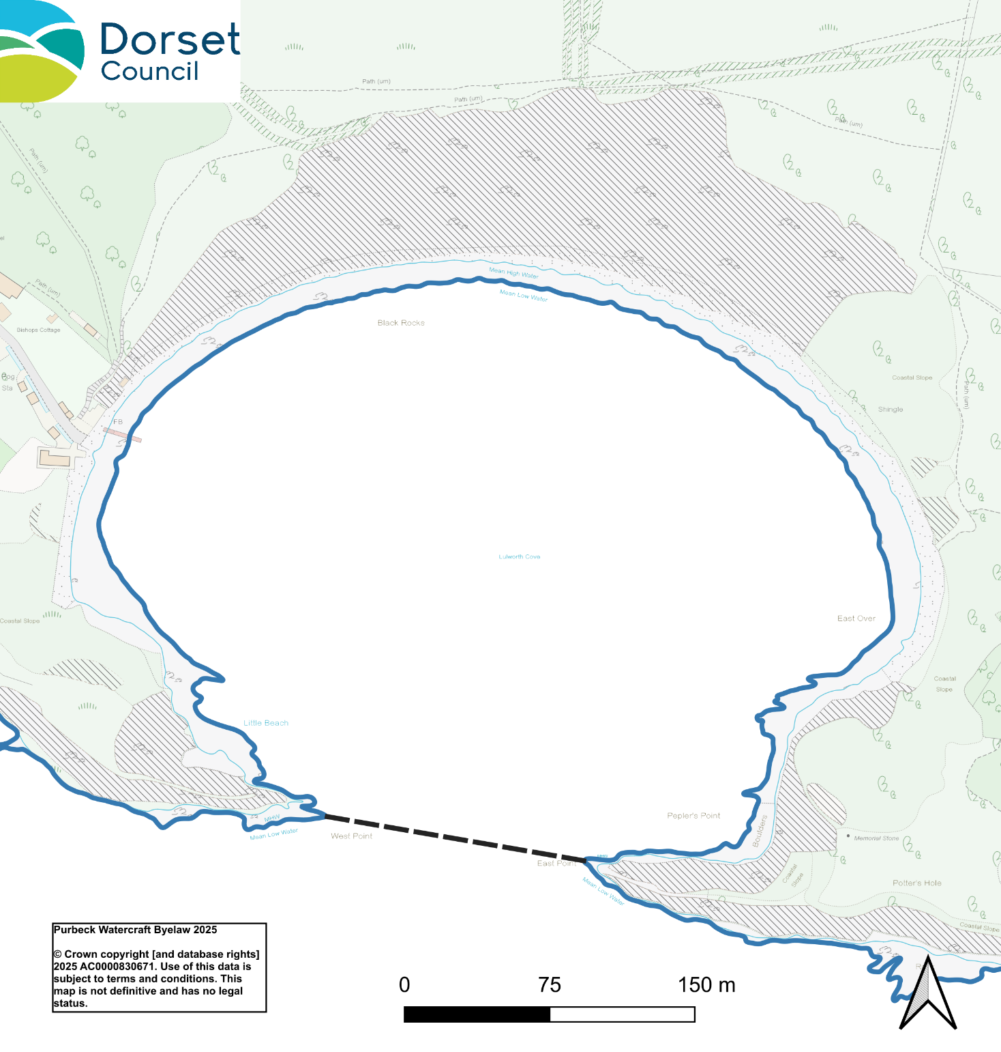
Map 1 - Lulworth Cove

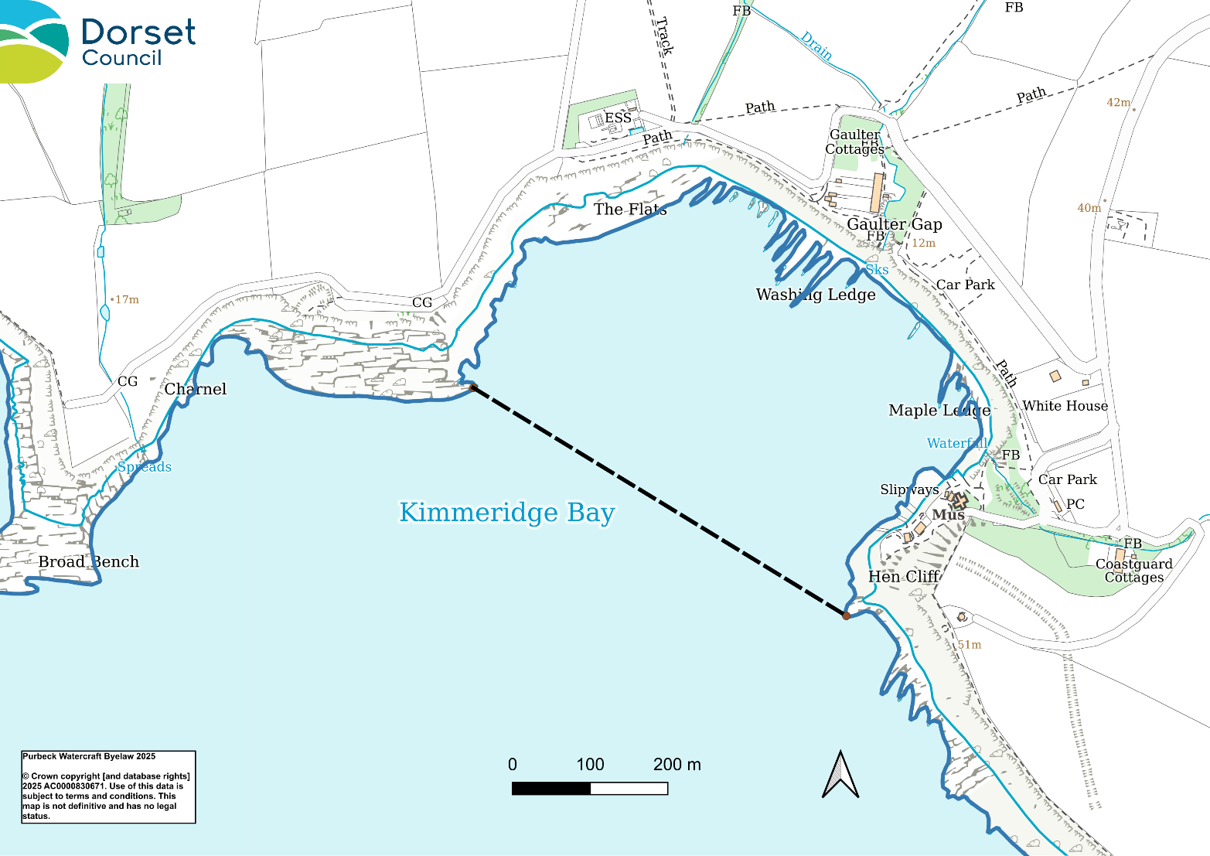
Map 2 - Kimmeridge bay

Map 3 – Swanage

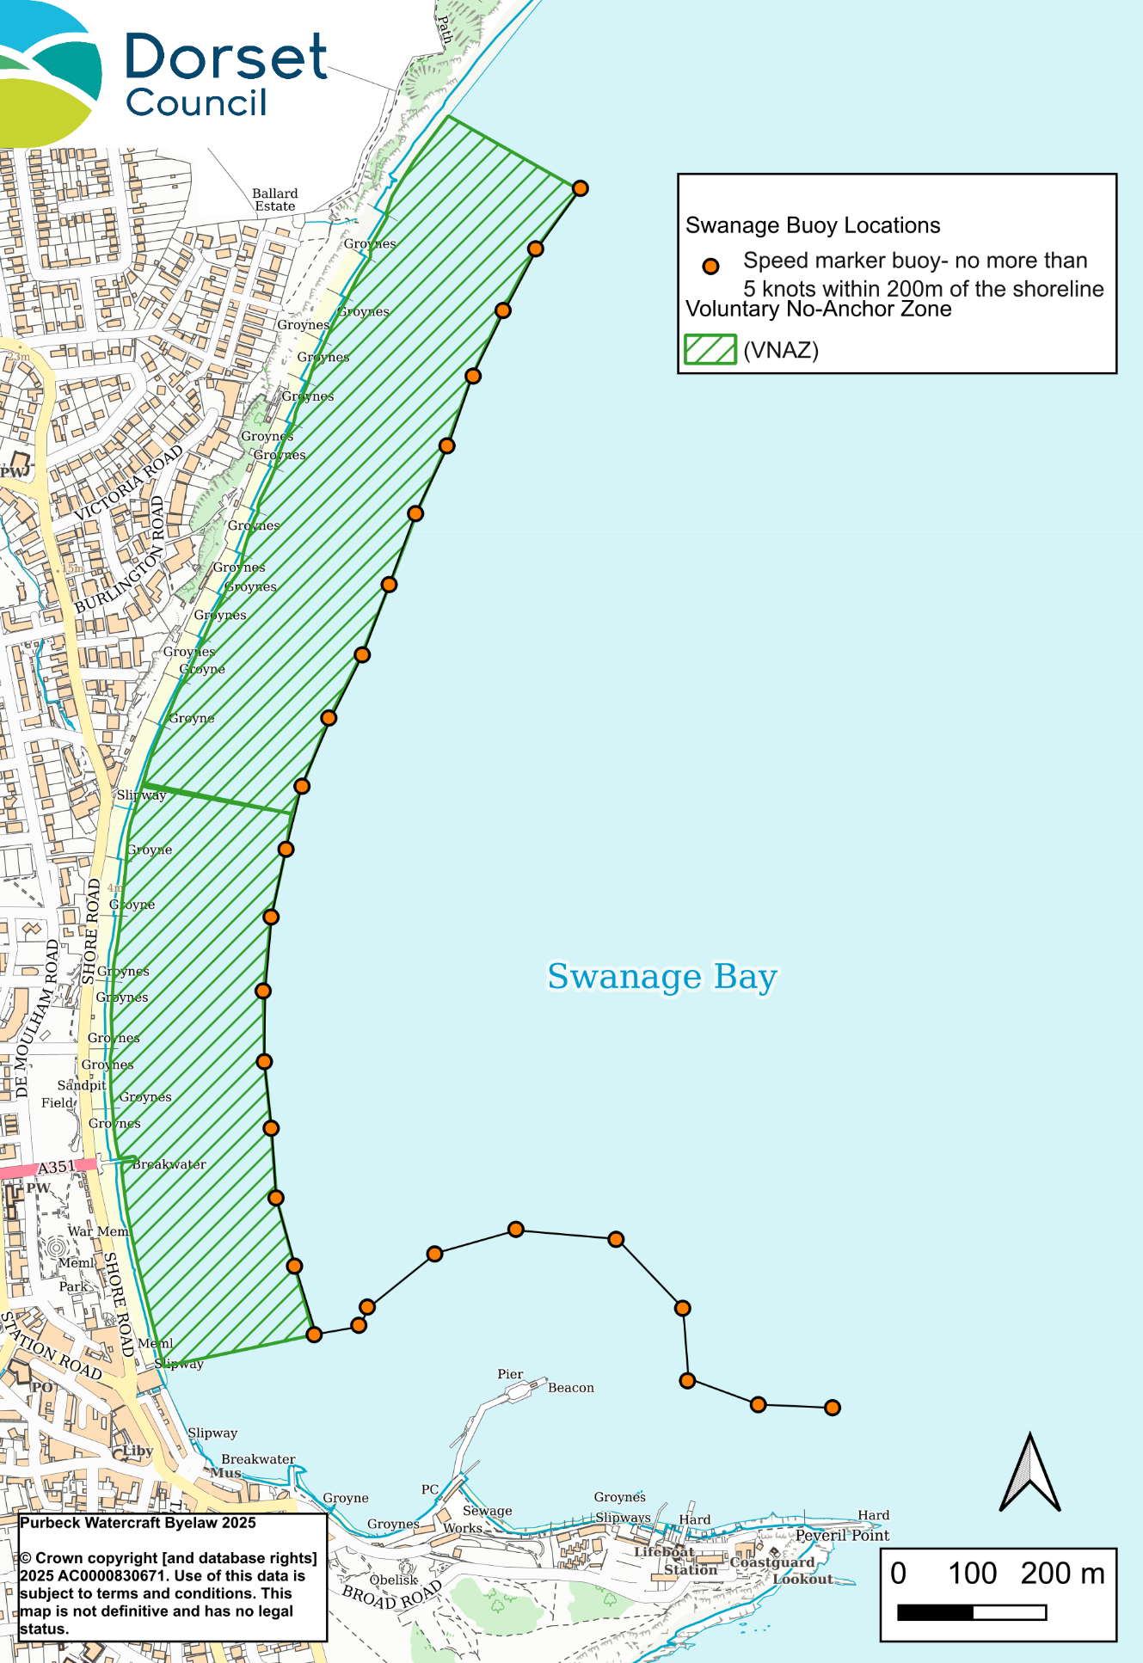

Map 4 – Studland

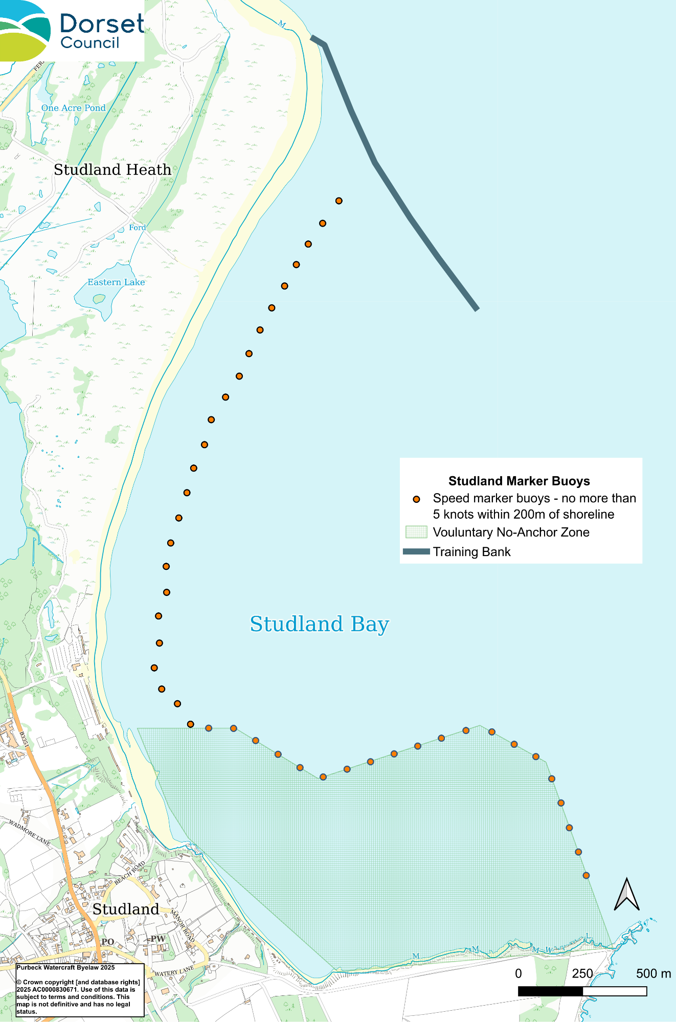

Explanatory Note
(this is not part of the byelaw)
Dorset Council, under section 76 of the Public Health Act 1961, enacts the Purbeck Watercraft Byelaw 2025. This byelaw, effective upon confirmation by the Secretary of State, imposes speed restrictions of 5 nautical miles per hour in specified areas, with additional speed marker buoys put out seasonally. It regulates watercraft operation, mandates care to avoid danger to people and wildlife, requires silencers on internal combustion engines, and outlines penalties for non-compliance. The byelaw does not affect Crown rights or public privileges and revokes the 2013 seaside pleasure boats byelaw.

